雍容人間 | 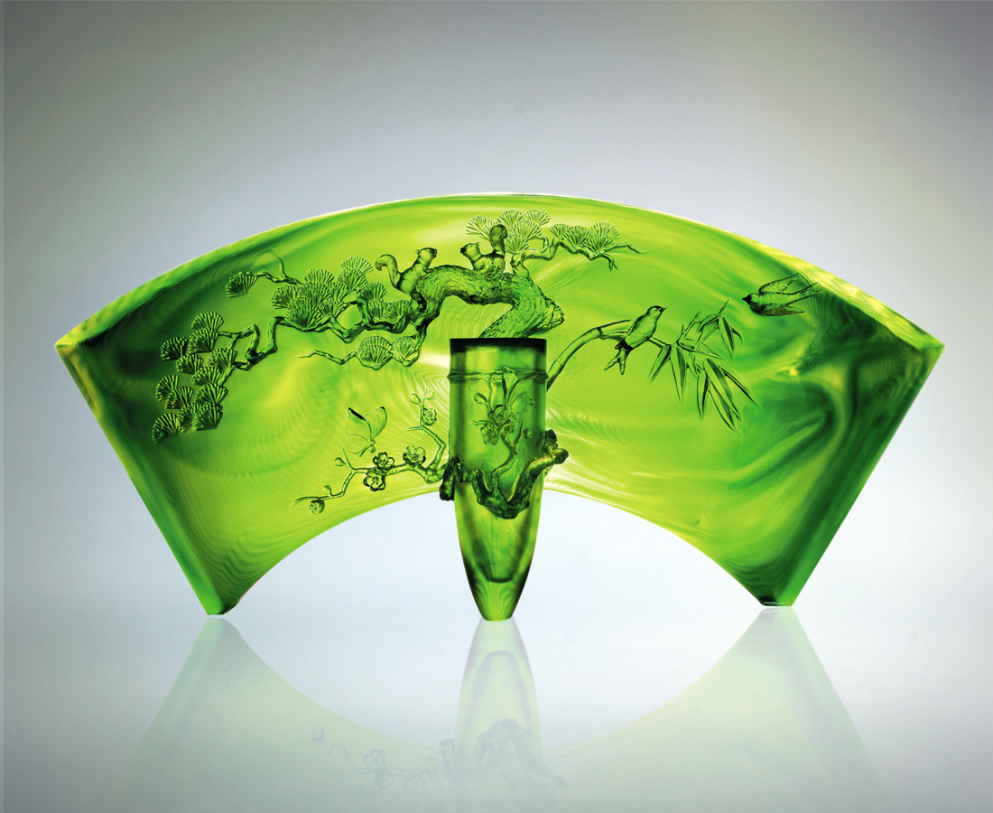
展開一扇雍容人間
態度謙沖 順風搖曳
智慧圓熟 順勢茁壯
堅忍務實 順時開花
而鳥語花香福報繽紛
人生隨喜 多元多福
A Splendid Life
Embark upon a life of noble splendor Going with the flow with humility Demonstrating core competencies with intellect Emanating maturity and perseverance Amidst nature’s magnificent panorama of flora and fauna Surround yourself with happiness, enjoying every aspect of living

編號 | 1402316 | No | 1402316
名稱 | 雍容人間 | Name | A Splendid Life
顏色 | 金綠透 | Color | golden, green,clear
尺寸 | 16.2 * 68 * 33.7 | Size | 16.2 * 68 * 33.7
重量 | 30.0 | Weight | 30.0
限量 | O | Limited Edition | O
售價 | NT$ 486800 | Price | NT$ 486800
 | RMB$ 91988 |  | RMB$ 91988

