夏遊 | 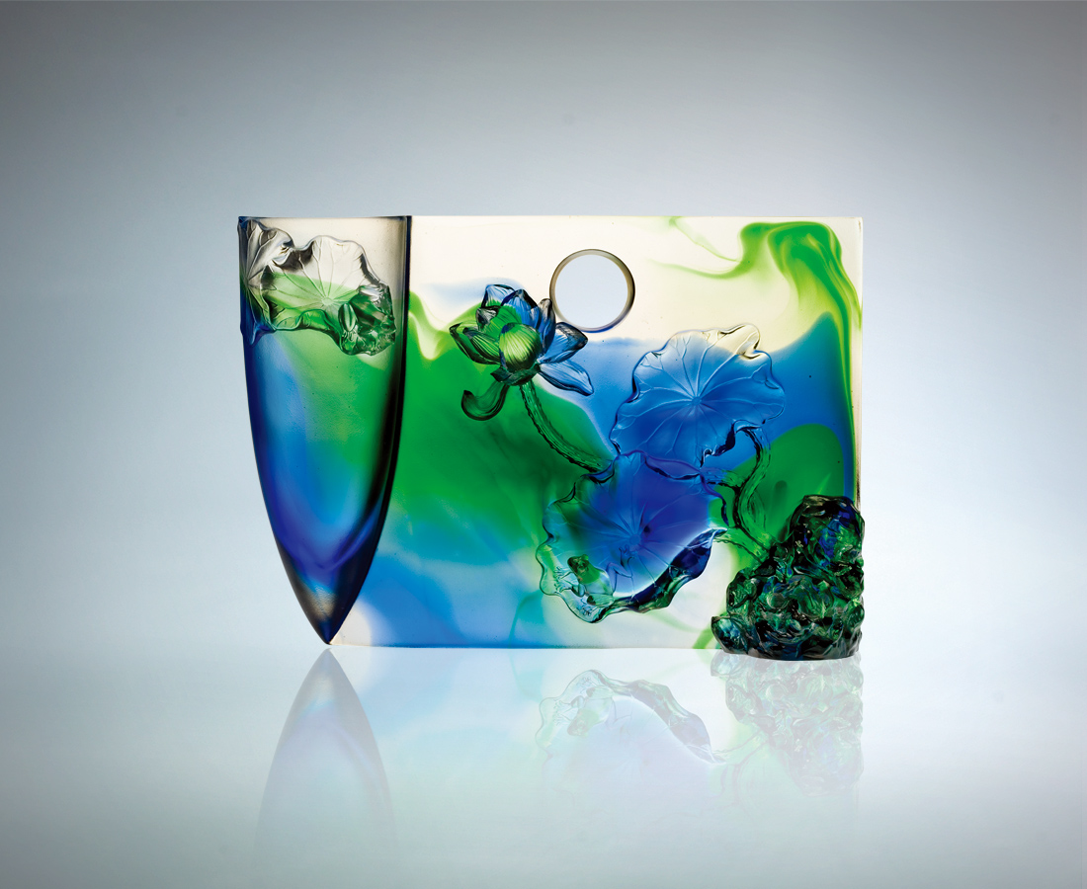
陽光鮮明召喚
回應華麗綻放
青春盡情 婀娜隨性
是風是雲 是靈是氣
瀰漫自我空性
遊悠無限風光
Summer Drifter
The sun beckons with a cheer; And life responds with a holler. Youthful spontaneity swinging with carefree serendipity. Be it the wind, the cloud, the spirit, or the air. The unburdened self wanders Through unbound wonders.

編號 | 1402211 | No | 1402211
名稱 | 夏遊 | Name | Summer Drifter
顏色 | 藍綠透 | Color | blue, green,clear
尺寸 | 8.6 * 25 * 17.5 | Size | 8.6 * 25 * 17.5
重量 | 2.75 | Weight | 2.75
限量 | O | Limited Edition | O
售價 | NT$ 47760 | Price | NT$ 47760
 | RMB$ 8260 |  | RMB$ 8260

