秋遷 | 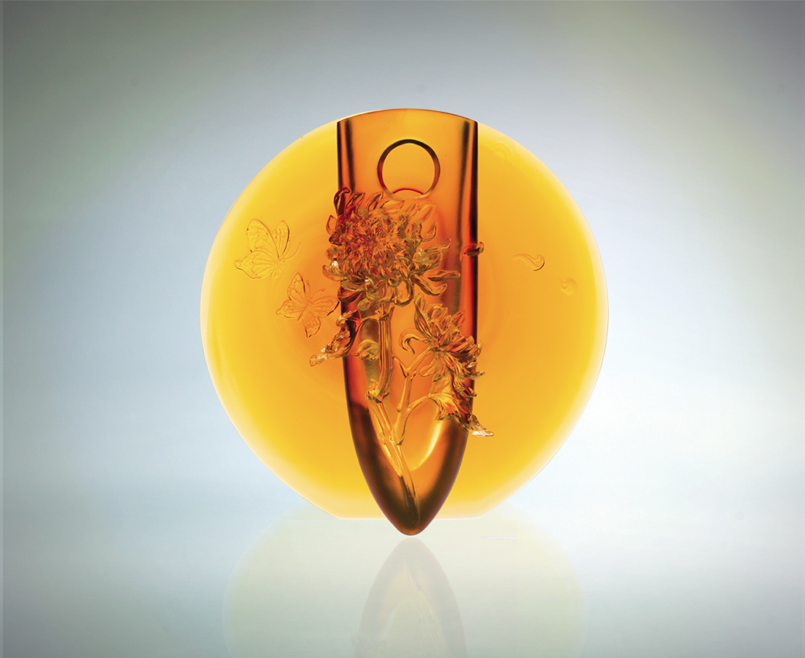
明月籠罩繽紛多層心思
識多見廣 隨緣隨喜
隨風飄散浪漫多情詩意
精益求精 更上層樓
緊守溫度 把握蛻變
就藉秋陽 脫胎換骨
Autumn Swing
The gradient thoughts of moon-lit sky Reveals layers of fickle moods and memory. Sway To – romantic and poetic along the drift Fro – escalating and energizing against the flow. Wrap that last trace of warmth around your finger for one more transformation Let the residual heat of summer bring about the final metamorphosis.

編號 | 1402210 | No | 1402210
名稱 | 秋遷 | Name | Autumn Swing
顏色 | 琥 | Color | amber
尺寸 | 8.6 * 20.9 * 21.1 | Size | 8.6 * 20.9 * 21.1
重量 | 2.42 | Weight | 2.42
限量 | O | Limited Edition | O
售價 | NT$ 42600 | Price | NT$ 42600
 | RMB$ 7460 |  | RMB$ 7460

