緣滿金玉 | 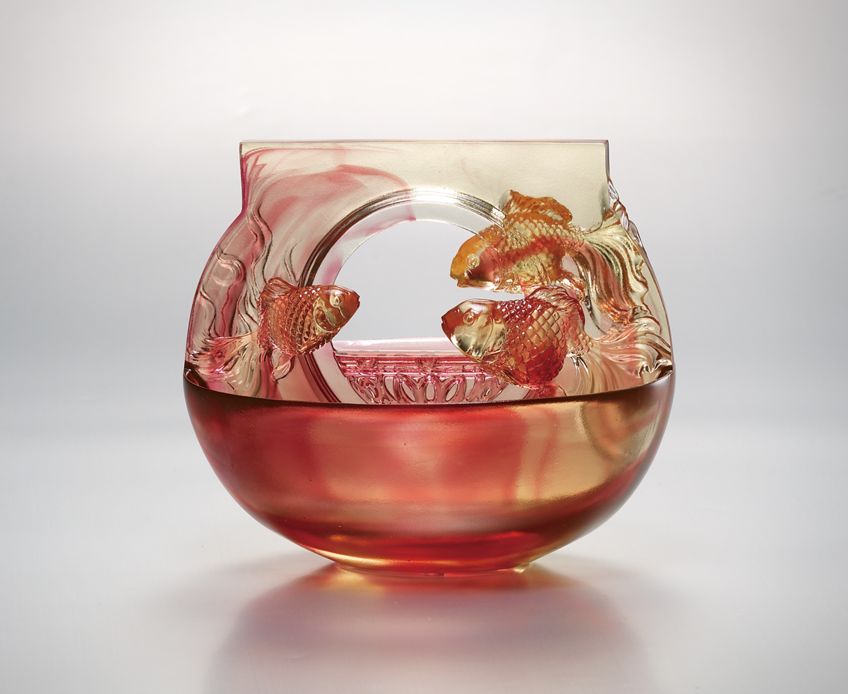
沒有天高 沒有地遠
只有信心愉悅的相遇
轉不完的真情 波波湧動
轉不盡的金玉 滿堂生輝
再圓荷喜平安的福器
Fortune Hidden in Golden Jade
No sky’s heights, no vastness of the earth Only the confident and joyful union That drives the circles of true love Never stops like relentless waves That forms the circle of gold and jade Shine all over the place Such an auspicious ware of happiness and blessings

編號 | 1402208 | No | 1402208
名稱 | 緣滿金玉 | Name | Fortune Hidden in Golden Jade
顏色 | 金紅 | Color | golden, red
尺寸 | 15 * 10.8 * 12.7 | Size | 15 * 10.8 * 12.7
重量 | 0.89 | Weight | 0.89
限量 | X | Limited Edition | X
售價 | NT$ 9050 | Price | NT$ 9050
 | RMB$ 2100 |  | RMB$ 2100

