山 | 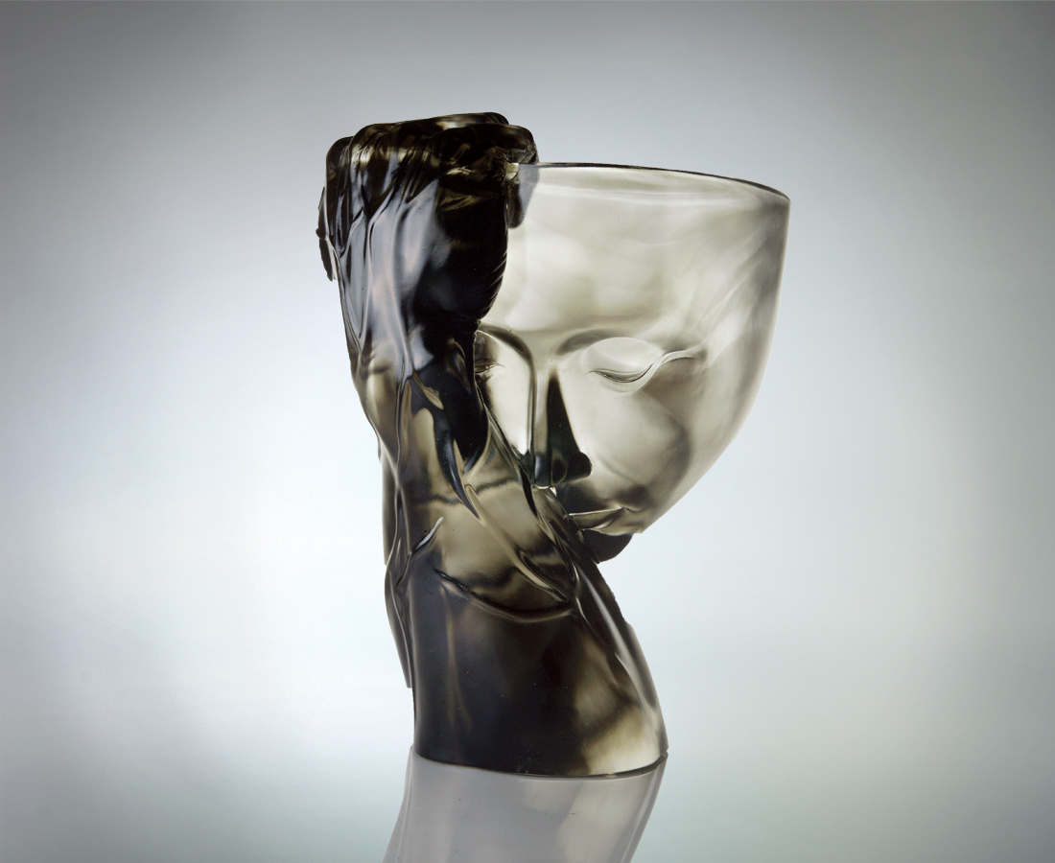
掌握
堅定如山
可渾厚 可聳拔
可登高 可望遠
它雄峙而前後有據
它守護而萬物蓬發
堅韌而主權在握
Mountain
Take control. Firm as the mountain. Solid slopes or steep ridges, Soaring high and ranging far, He guards with a solid foundation, and He protects for a blooming vitality. Adamant and sovereign.

編號 | 1402206 | No | 1402206
名稱 | 山 | Name | Mountain
顏色 | 灰透 | Color | gray, clear
尺寸 | 20.2*25*32.4 | Size | 20.2*25*32.4
重量 | 13.9 | Weight | 13.9
限量 | O | Limited Edition | O
售價 | NT$ 72600 | Price | NT$ 72600
 | RMB$ 15966 |  | RMB$ 15966

