溫馨滿懷 | 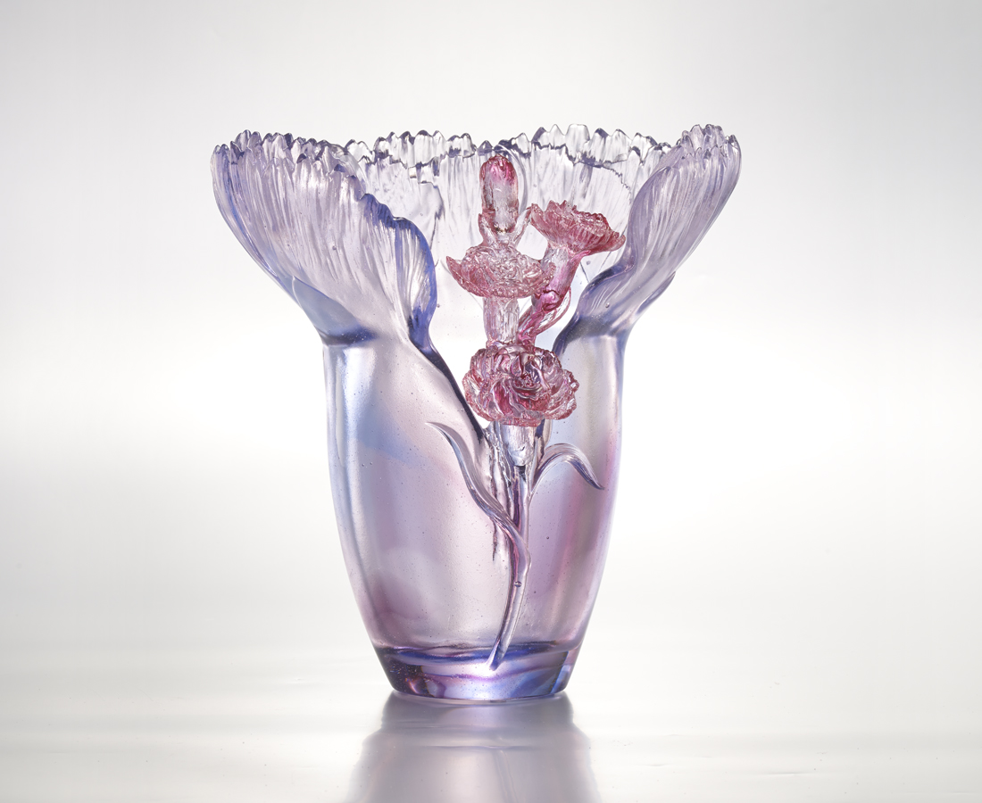
綻放
學習 無私的關懷
開展 滿懷的信任
豁然 朗朗歡喜的圓融
不渝 相契相惜的真情
在遊動的潮流
但見溫馨滿懷的雍容
Comforting Compassion
Blooming, It learns selfless care And opens doubtless embrace. Extended arms encircle bundles of joy; Trusted friends build a fortress of love. In the midst of transient current, Remains the gentle face of compassion.

編號 | 1402204 | No | 1402204
名稱 | 溫馨滿懷 | Name | Comforting Compassion
顏色 | 藍紫透 | Color | blue, purple, clear
尺寸 | 16.9 * 22.8 * 24.3 | Size | 16.9 * 22.8 * 24.3
重量 | 4.25 | Weight | 4.25
限量 | O | Limited Edition | O
售價 | NT$ 44860 | Price | NT$ 44860
 | RMB$ 11222 |  | RMB$ 11222

