真情洋溢 | 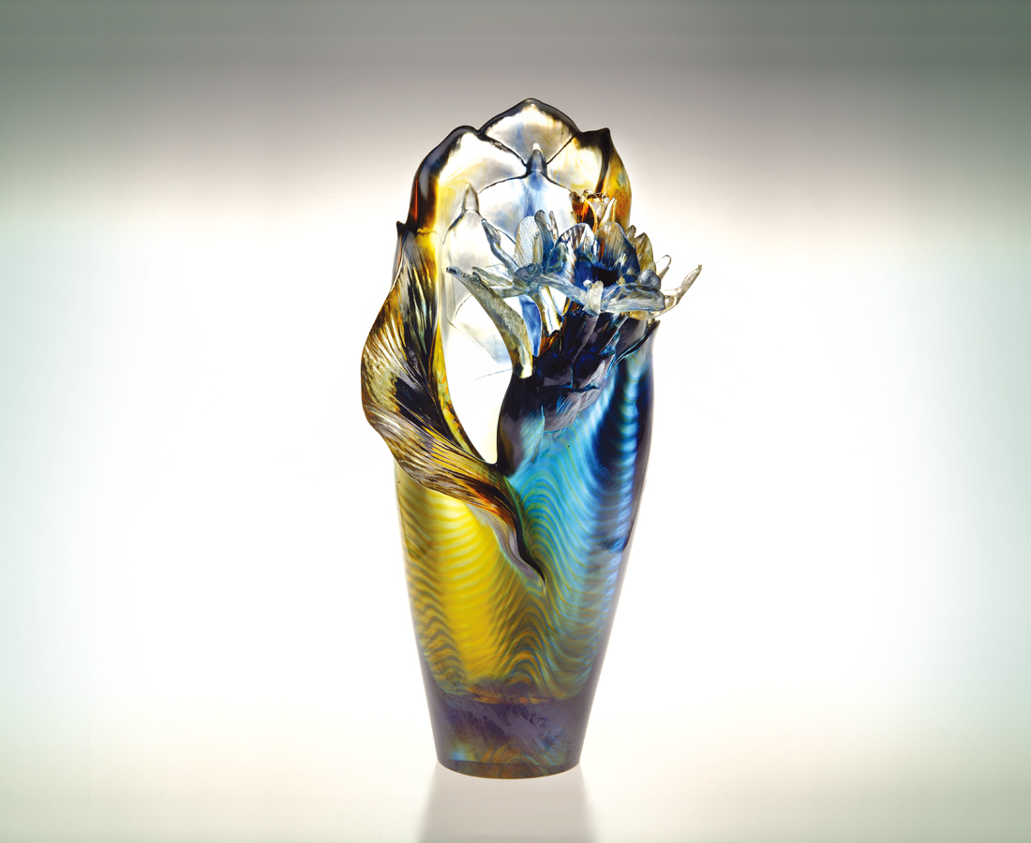
搖曳
學習 真誠的坦率
綻放 隨性的美麗
蔚然 飄送濃郁的情意
不求 施放自得的繽紛
在遊動的潮流
但見真情流露的嬌豔
Unveiled Passion
Swaying, It learns the frankness of sincerity And shows the beauty of spontaneity. Lush sentiment travels with openness; Joyful brilliance fills with unreservedness. In the midst of shifting current, Flashes the glance of honest passion.

編號 | 1402203 | No | 1402203
名稱 | 真情洋溢 | Name | Unveiled Passion
顏色 | 藍琥透 | Color | blue, amber, clear
尺寸 | 21.7 * 15.7 * 33.2 | Size | 21.7 * 15.7 * 33.2
重量 | 5.91 | Weight | 5.91
限量 | O | Limited Edition | O
售價 | NT$ 44680 | Price | NT$ 44680
 | RMB$ 11166 |  | RMB$ 11166

