春奔 | 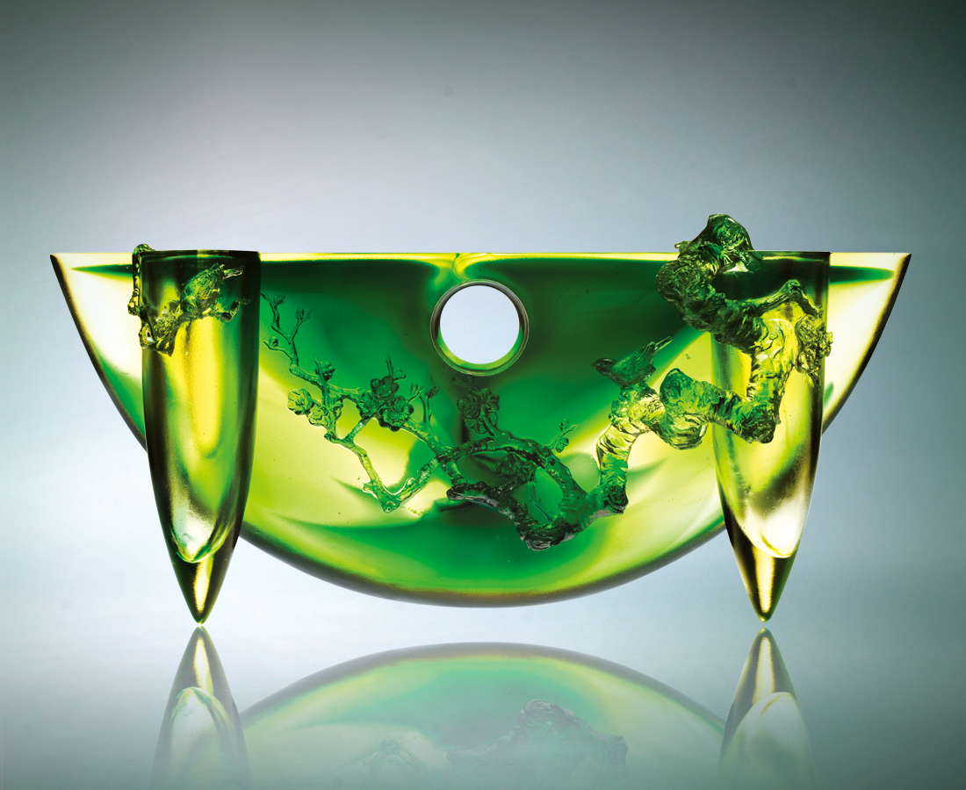
見過無數日月
一季又一季
遍歷曲折伏蟄
一節又一節
迂迴堅守 不疾不徐
終於芳香鳥語
再奔初陽的豔麗
Sprint of Spring
Season after season, Witness the rise and fall of countless moons. Chapter after chapters, Experience the twists and turns of hidden danger. Persistence guides as prudence paces Towards…at last… the sprint For the brilliant blossoms of Spring.

編號 | 1402187 | No | 1402187
名稱 | 春奔 | Name | Sprint of Spring
顏色 | 金綠 | Color | golden, green
尺寸 | 9.2 * 33.4 * 15.5 | Size | 9.2 * 33.4 * 15.5
重量 | 3.66 | Weight | 3.66
限量 | O | Limited Edition | O
售價 | NT$ 54680 | Price | NT$ 54680
 | RMB$ 9260 |  | RMB$ 9260

