華麗態勢 | 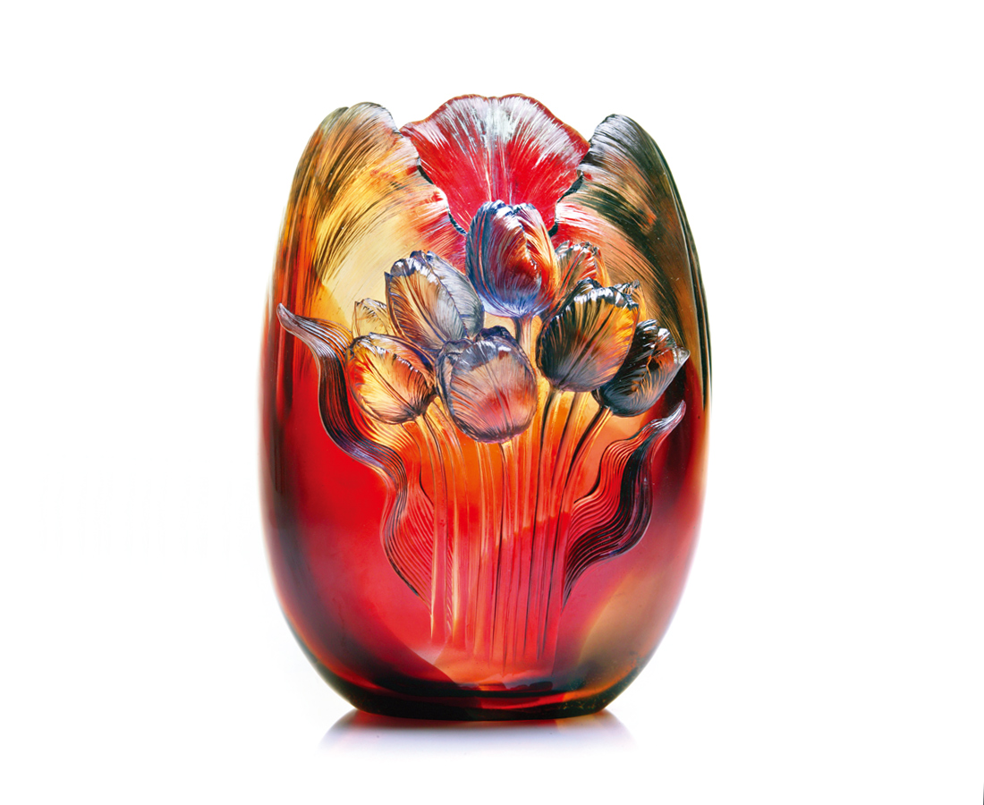
沉著
學習 均衡的穩重
醞釀 飽滿的自信
安然 吸收典雅的風采
不停 聚足堅忍的態勢
在遊動的潮流
但見端莊的華麗
Luxurious Stance
Composure. Learning the stateliness of balance Nurturing the richness of confidence. Steadily, it gathers the aura of classicism; Ceaselessly, it secures the stance of endurance. In the midst of swift current, Surges the luxury of elegance.

編號 | 1402185 | No | 1402185
名稱 | 華麗態勢 | Name | Luxurious Stance
顏色 | 紅藍茶透／金藍／金琥 | Color | red, blue, brown, clear／golden, blue／ golden, amber
尺寸 | 16.6 * 19.8 * 26 | Size | 16.6 * 19.8 * 26
重量 | 6.3 | Weight | 6.3
限量 | O | Limited Edition | O
售價 | NT$ 44860 | Price | NT$ 44860
 | RMB$ 11222 |  | RMB$ 11222

