同心合意 | 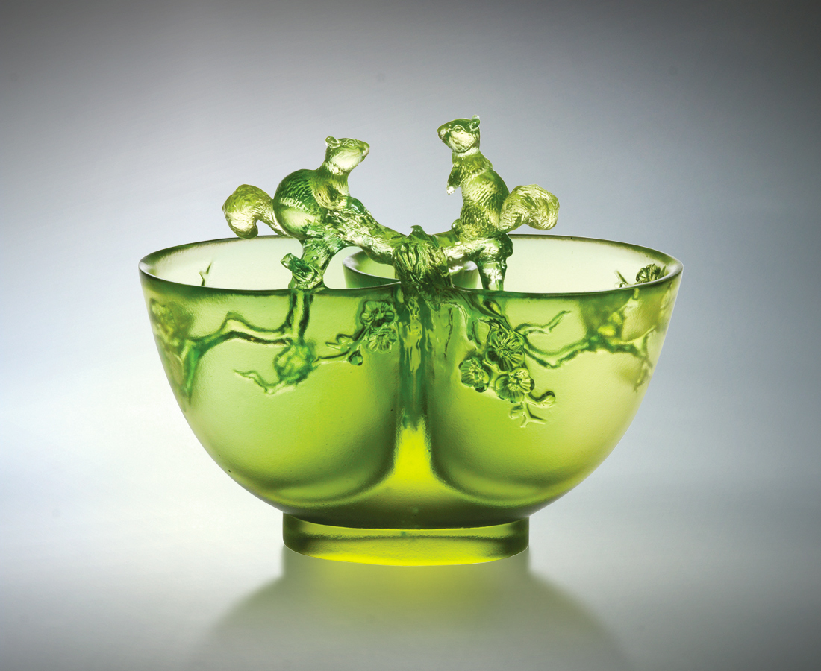
曾經東奔西跑
交換春夏見聞
曾經穿越秋冬
交集梅開飄香
同心 坦蕩相見
合意 真情包容
為無邊理想視野 以誠相交
為生生不息因緣 以信相守
Kindred Spirits
Once we wandered through the cities Exchanging our seasoned thoughts. Once we crossed through wildernesses, Sharing our fragrant memories. One at heart with sincerity as our bond One in mind with compassion as our guide Honesty paves our way toward our goals while Trust guards our friendship forever.

編號 | 1402176 | No | 1402176
名稱 | 同心合意 | Name | Kindred Spirits
顏色 | 金綠 | Color | golden, green
尺寸 | 7.2 * 13.2 * 11.2 | Size | 7.2 * 13.2 * 11.2
重量 | 0.69 | Weight | 0.69
限量 | X | Limited Edition | X
售價 | NT$ 6380 | Price | NT$ 6380
 | RMB$ 1588 |  | RMB$ 1588

