大道行 | 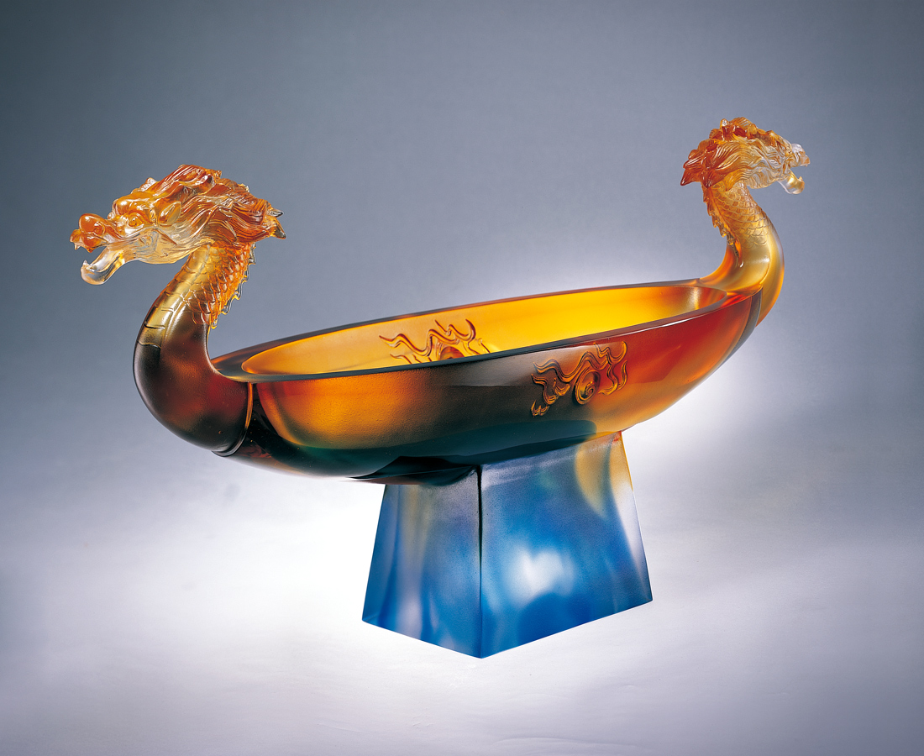
心懷太虛 無量吸收
容五湖四海澎湃情義
前瞻後顧 無窮焦點
集古今中外真知灼見
行光明磊落開闊步伐
至水到渠成圓滿境地
大道行
正氣如龍 氣勢浩然
Journeying towards a brighter future
Harboring emptiness, absorbing without limit Embracing comradeship from all corners of the land Thinking before acting, possessing multiple focal points Accumulating deep insight and genuine knowledge from time immemorial Progressing with open-mindedness and righteousness Towards the land of assured success Journeying towards a brighter future With a sense of honesty and integrity, and a carefree soul

編號 | 1402084 | No | 1402084
名稱 | 大道行 | Name | Journeying towards a brighter future
顏色 | 藍琥透 | Color | blue, amber, clear
尺寸 | 12.1 * 48 * 23 | Size | 12.1 * 48 * 23
重量 | 5.9 | Weight | 5.9
限量 | O | Limited Edition | O
售價 | NT$ 99800 | Price | NT$ 99800
 | RMB$ 24966 |  | RMB$ 24966

