登高 | 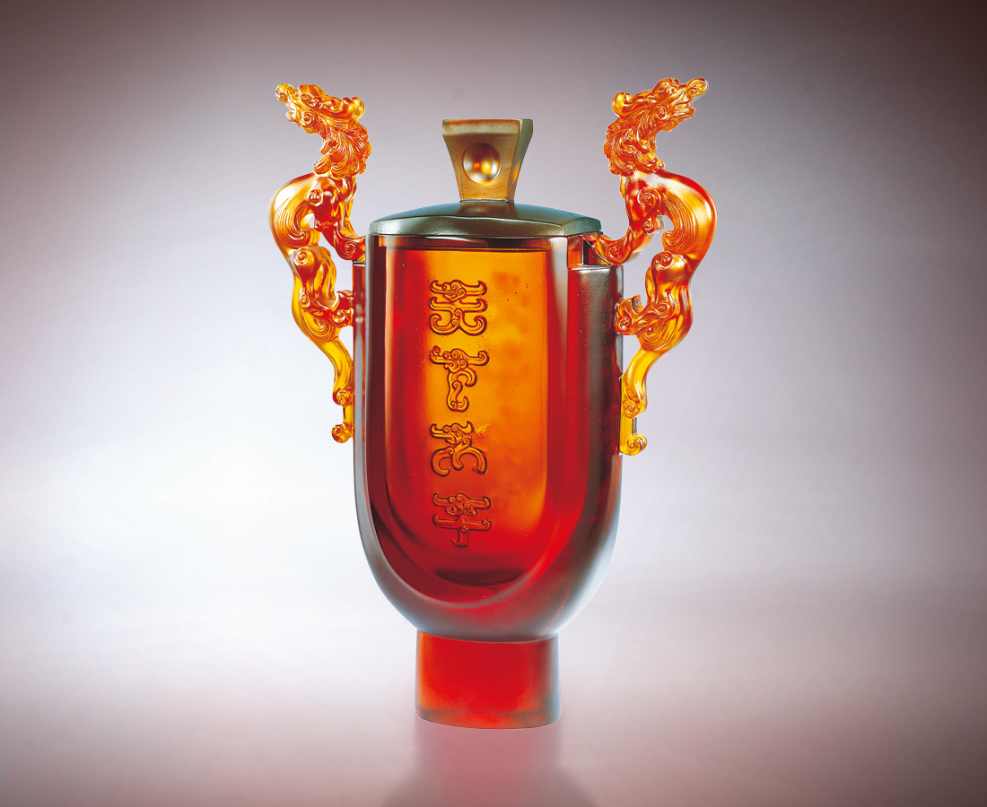
登高遠望 先知先覺
緊守前程光明的方向
登高驚覺 未雨綢繆
緊守應變沉著的節奏
登高倫理 有守有節
緊守大公無私的原則
於大我 天下太平
於小我 大千和合
Climb High
Broaden your perspective to stay informed and be prepared Monitor your progress towards a bright future Always be aware and prepare for unexpected changes Keeping up the momentum of adapting to change Always ensure compliance with ethics Walking the talk of ethical behavior selflessly From a macro perspective, peace on earth At a personal level, living in harmony

編號 | 1402072 | No | 1402072
名稱 | 登高 | Name | Climb High
顏色 | 琥／藍 | Color | amber／blue
尺寸 | 8.5 * 22 * 29.6 | Size | 8.5 * 22 * 29.6
重量 | 3.99 | Weight | 3.99
限量 | O | Limited Edition | O
售價 | NT$ 51620 | Price | NT$ 51620
 | RMB$ 11860 |  | RMB$ 11860

