正氣 | 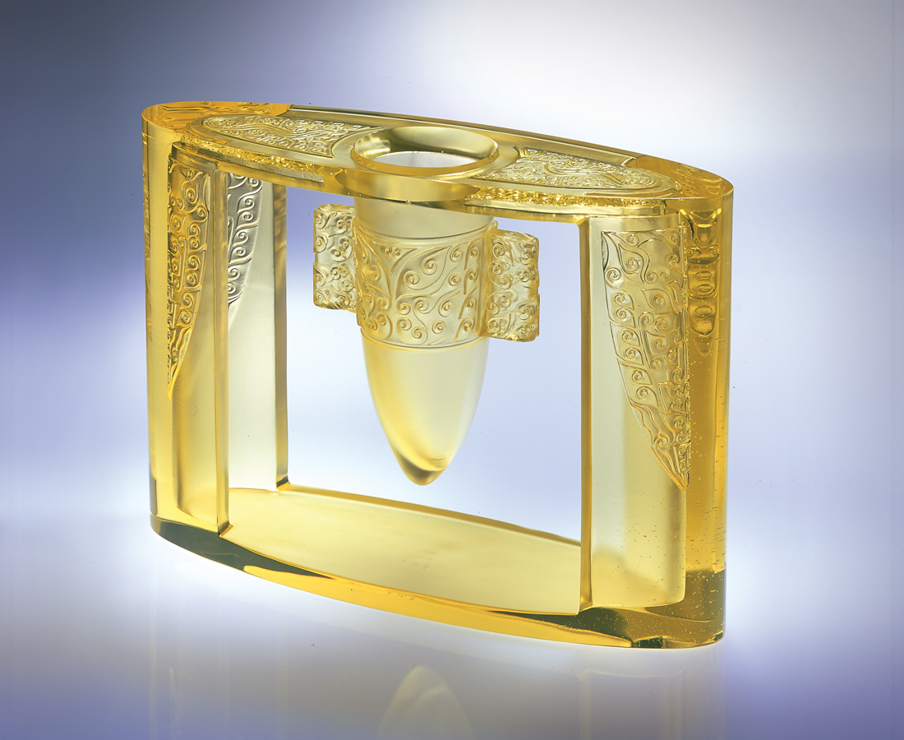
方正不阿 威武凜然
規矩內省 聚足威勢
深藏智德 蘊藉富足
而 曰不屈不移不朽
Noble Heroism
With focused mind and unwavering determination Playing by the rules with valor Possessing immense intellect and morals, generating fortune Yet never yielding nor pretentious, living on forever

編號 | 1401016 | No | 1401016
名稱 | 正氣 | Name | Noble Heroism
顏色 | 金 | Color | golden
尺寸 | 10.5 * 33.7 * 24.6 | Size | 10.5 * 33.7 * 24.6
重量 | 9.6 | Weight | 9.6
限量 | X | Limited Edition | X
售價 | NT$ 166000 | Price | NT$ 166000
 | RMB$ 41522 |  | RMB$ 41522

