天地良緣 | 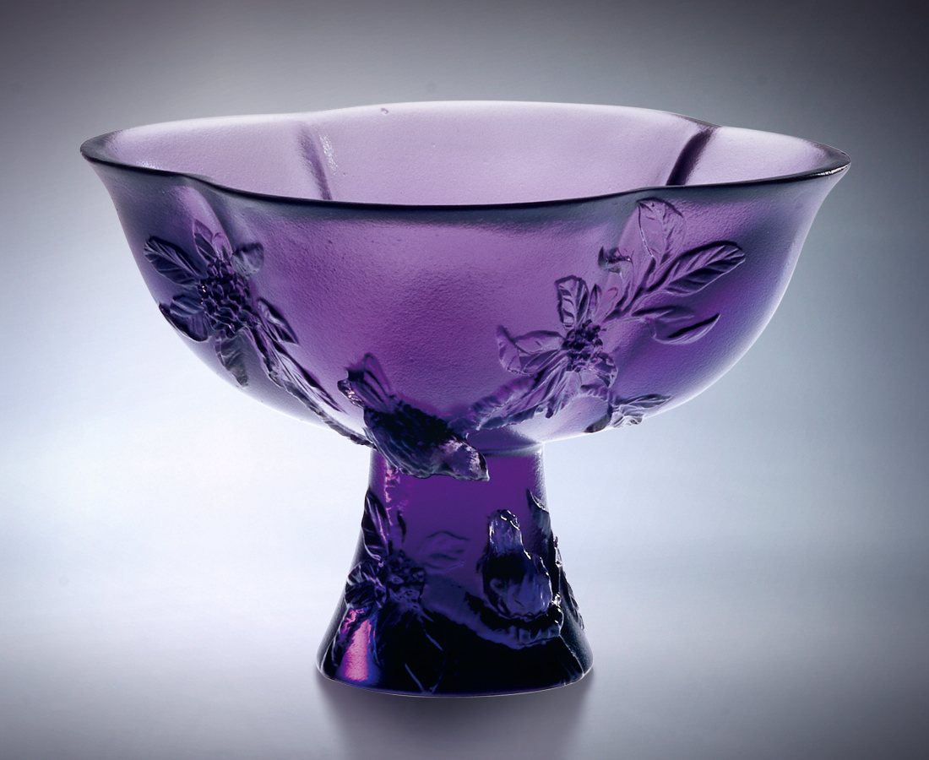
不比一枝獨秀
但有繁花幽香
不比一時爭豔
但要意長情久
隨著節氣定時花開
隨著氣運飛上枝頭
持久漸近 步伐穩健
斟一口淡雅的桂花醉意
歡喜共享 心願長伴
The Most Blessing Marriage
I don’t wish to be an eminent bloom among many flowers. But I wish to give off the fragrance. I don’t wish to participate in the competition for the best partner if I cannot secure a long-term friendship and intimate union. I bloom at the tempo designated by the Chinese solar terms, acknowledging my destiny to win the laureate. My action lasts. I achieve the state of happiness with steady steps. Let’s drink a cup of light osmanthus liquor together. We constantly remind ourselves of the sweet time we share together, and wish we can accompany each other forever.

編號 | 1400241 | No | 1400241
名稱 | 天地良緣 | Name | The Most Blessing Marriage
顏色 | 紫 | Color | purple
尺寸 | 6.9 * 6.9 * 5.5 | Size | 6.9 * 6.9 * 5.5
重量 | 0.11 | Weight | 0.11
限量 | X | Limited Edition | X
售價 | NT$ 3360 | Price | NT$ 3360
 | RMB$ 788 |  | RMB$ 788

