尊貴一世─雙頭龍紋 | 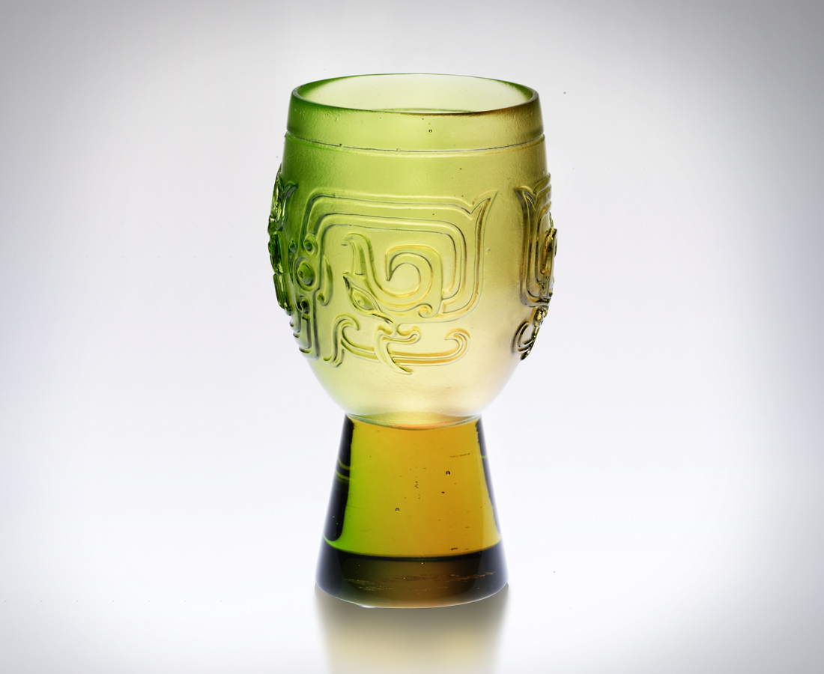
華貴典雅 克己復禮
文武兼備 笑傲山河
一雙手
緊握俠骨柔情風範
一張嘴
暢飲一口雍容自在
一對眼
見證一片風雲際會
為詭變世局 氣定神閒
為運籌經緯 天生好手
Lifelong Nobility
Magnificence and elegance, self-restraint and restoration of the rites, Standing aloft in the world with both polite letters and martial arts; Two hands hold the manners of justice and tenderness, A mouth utters easiness and leisure; Two eyes witness the upheaval of the world, Changeable situation can be tackled by composedness; Innate talents can operate outstandingly under any circumstances.

編號 | 1400207 | No | 1400207
名稱 | 尊貴一世─雙頭龍紋 | Name | Lifelong Nobility
顏色 | 琥綠 | Color | amber, green
尺寸 | 5.9 * 5.9 * 9.8 | Size | 5.9 * 5.9 * 9.8
重量 | 0.2 | Weight | 0.2
限量 | X | Limited Edition | X
售價 | NT$ 4280 | Price | NT$ 4280
 | RMB$ 988 |  | RMB$ 988

