雍容四方 | 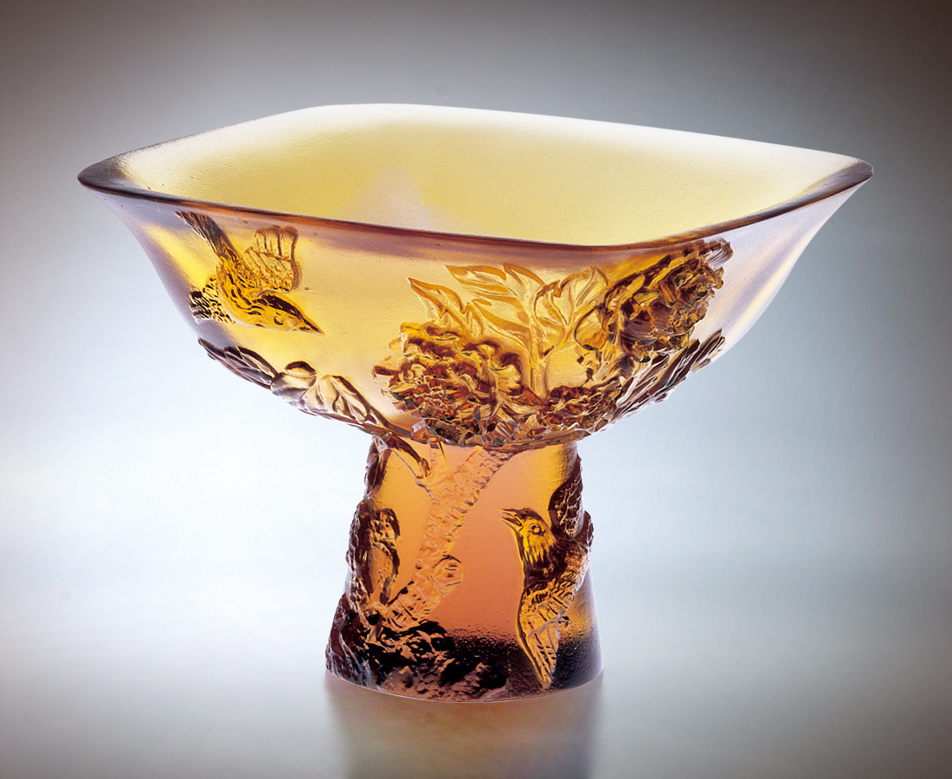
在盤根錯節的堅石裡
不少花團錦簇的燦爛
在南來北往的追逐中
不忘夢想實踐的真情
目標向上 方向一同
你我交會在美麗新境
斟一口熱誠的牡丹醉意
雍容四方 富貴迎人
The Elegant Appearance Encounters Everywhere
In a stately stone with myriad twisted roots and knots, there is daggling beauty of blossoms. In the conquests from south to north, there is passion to realize their dreams sharing the same goals. You and I will meet together again in the great new world. Let’s drink a cup of the peony liquor to greet everyone and elegantly and a great host for people from everywhere.

編號 | 1400200 | No | 1400200
名稱 | 雍容四方 | Name | The Elegant Appearance Encounters Everywhere
顏色 | 琥 | Color | amber
尺寸 | 7 * 7 * 5.2 | Size | 7 * 7 * 5.2
重量 | 0.11 | Weight | 0.11
限量 | X | Limited Edition | X
售價 | NT$ 3360 | Price | NT$ 3360
 | RMB$ 788 |  | RMB$ 788

