品味莊嚴─回頭龍紋 | 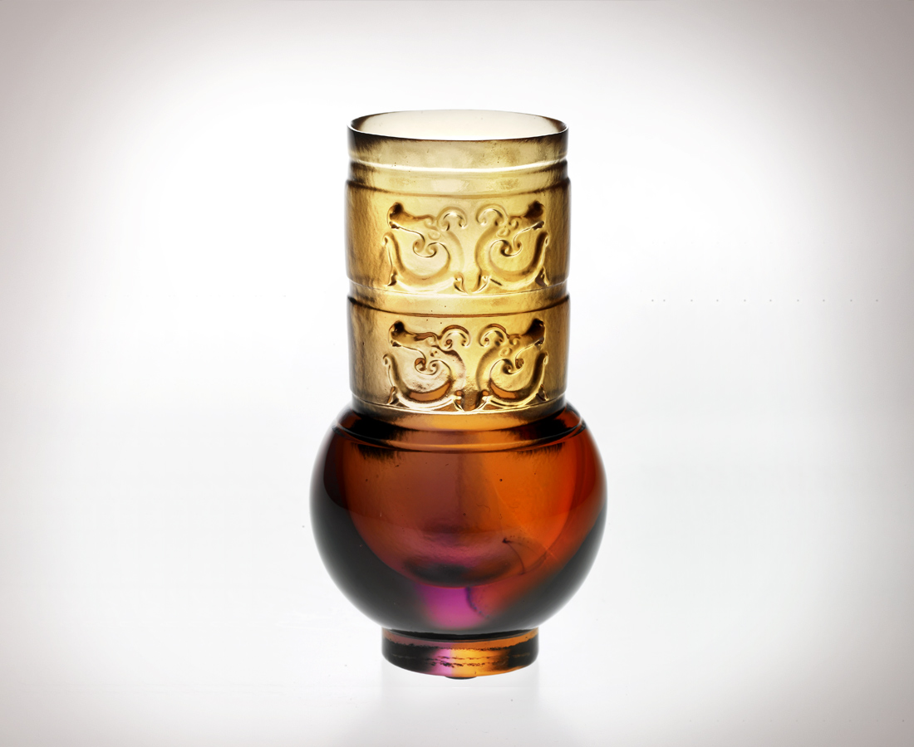
神聖莊嚴 一絲不茍
方圓規矩 層次有序
一雙手
緊握逐鹿天下勝算
一張嘴
暢飲一口深情期許
一對眼
見證一段自我挑戰
為繽紛世事 眼觀四面
為渾沌沉澱 耳聽八方
Solemn Taste
Sacred solemnity is meticulously presented, Rules and regulations are orderly arranged; Two hands hold the knack to the mastery of the world closely, A mouth utters profound expectation; Two eyes witness self-challenge with sharp observation of worldly affairs; While two ears are so sensitive to what is going on in all directions.

編號 | 1400195 | No | 1400195
名稱 | 品味莊嚴─回頭龍紋 | Name | Solemn Taste
顏色 | 琥紫 | Color | amber, purple
尺寸 | 5.4 * 5.4 * 10 | Size | 5.4 * 5.4 * 10
重量 | 0.25 | Weight | 0.25
限量 | X | Limited Edition | X
售價 | NT$ 4280 | Price | NT$ 4280
 | RMB$ 988 |  | RMB$ 988

