尊貴一世─獸帶紋 | 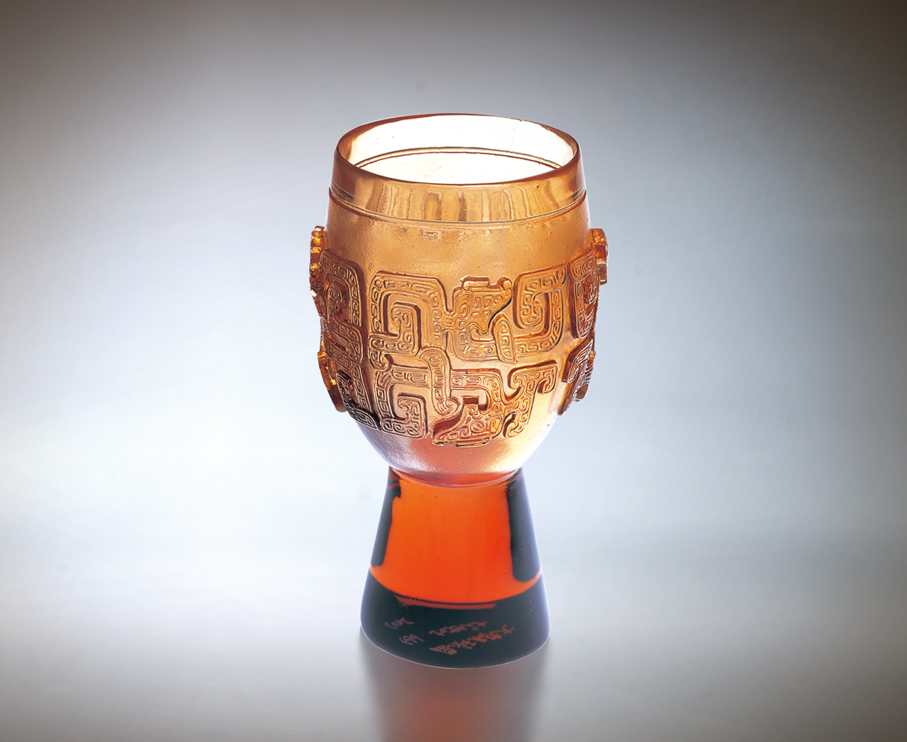
華貴典雅 克己復禮
文武兼備 笑傲山河
一雙手
緊握俠骨柔情風範
一張嘴
暢飲一口雍容自在
一對眼
見證一片風雲際會
為詭變世局 氣定神閒
為運籌經緯 天生好手
Lifelong Nobility
Adorned in elegance and nobility Facing the world fully competent A pair of hands Firmly grasping the passion of heroes The mouth Spouting unrestrained freedom A pair of eyes Witnessing noble events Creating calmness and sensitivity to meet any change Leveraging heaven’s gift to prepare to cultivate success

編號 | 1400194 | No | 1400194
名稱 | 尊貴一世─獸帶紋 | Name | Lifelong Nobility
顏色 | 琥紫 | Color | amber, purple
尺寸 | 5.9 * 5.9 * 9.8 | Size | 5.9 * 5.9 * 9.8
重量 | 0.2 | Weight | 0.2
限量 | X | Limited Edition | X
售價 | NT$ 4280 | Price | NT$ 4280
 | RMB$ 988 |  | RMB$ 988

