縱情四海-雙羊紋 | 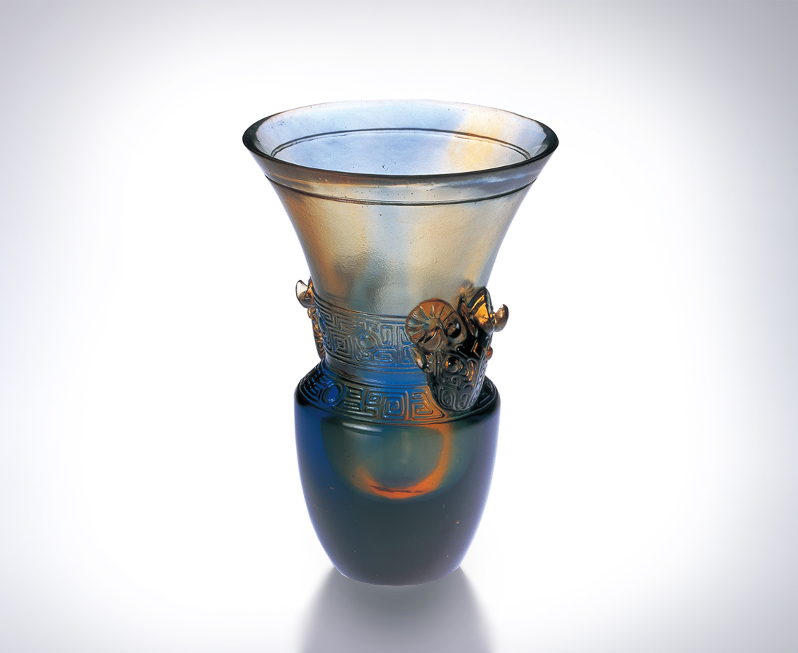
開闊心胸 廣納四海
調整視角 面對挑戰
一雙手
緊握千秋萬世豪情
一張嘴
暢飲一口九鼎承諾
一對眼
見證一抹似水柔情
為有頭有臉 出奇制勝
為有情有義 開創新猷
Undaunted Spirit
Traveling the open seas with an open heart Adapting constantly to meet every challenge A pair of hands Firmly grasping infinite majestic energy The mouth Spouting promises of fortune and prosperity A pair of eyes Witnessing eternal love Generating success for power and stature Developing new relationships for kinship and love

編號 | 1400182 | No | 1400182
名稱 | 縱情四海-雙羊紋 | Name | Undaunted Spirit
顏色 | 琥藍 | Color | amber, blue
尺寸 | 7 * 7 * 10 | Size | 7 * 7 * 10
重量 | 0.23 | Weight | 0.23
限量 | X | Limited Edition | X
售價 | NT$ 4280 | Price | NT$ 4280
 | RMB$ 988 |  | RMB$ 988

