悠蘭自在 | 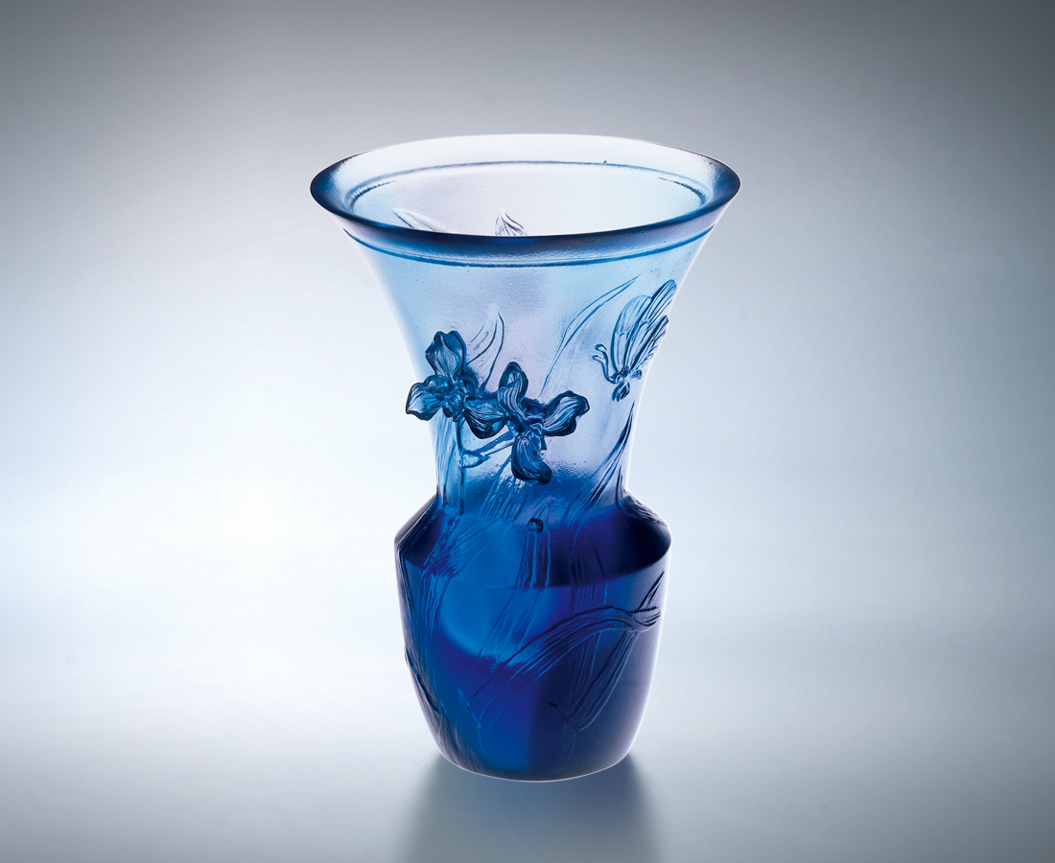
聞風起舞 順應潮流
化蝶彩翼 無拘無束
一雙眼 只見隨遇而安空性
一顆心 體會圓融周延自在
一張嘴 歌頌風生水起際會
為清新脫俗 悠然安住
為隨喜自得 當下陶醉
The Liberal Locating Orchid
I dance to the breeze and follow the flows . I transform into a beautiful butterfly flying in the sky without any strings. I closed my eyes to mediate upon the emptiness and to accommodate myself to the environments. I understood the perfection and comprehensiveness in the free state of mind. I praise the encounters brought together by chance. The beautiful and elegant orchid is independently rooted here to appreciate the fresh and gentle breeze. At the moment ,I am deeply immersed in the beauty of the orchid.

編號 | 1400116 | No | 1400116
名稱 | 悠蘭自在 | Name | The Liberal Locating Orchid
顏色 | 青紫 | Color | cyan, purple
尺寸 | 6.9 * 6.9 * 10 | Size | 6.9 * 6.9 * 10
重量 | 0.23 | Weight | 0.23
限量 | X | Limited Edition | X
售價 | NT$ 4280 | Price | NT$ 4280
 | RMB$ 988 |  | RMB$ 988

