情深愉悅 | 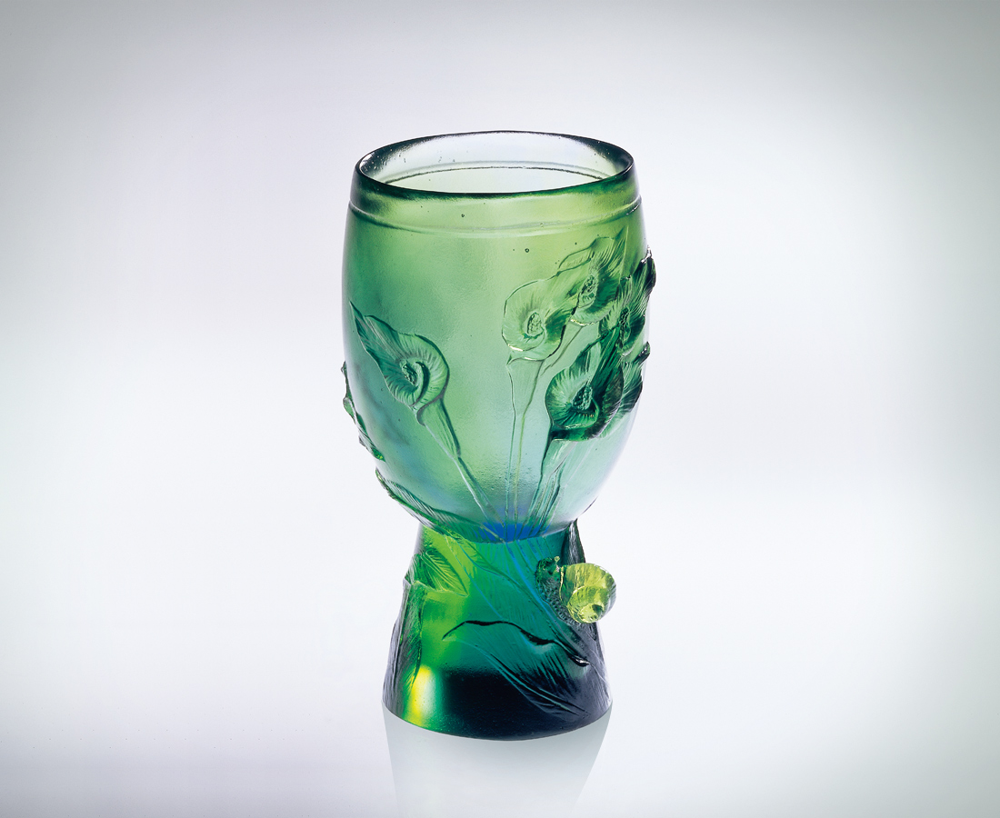
靜心慢行 處處風景
順勢上陞 登高眺望
一雙眼 只見海闊天空悠然
一顆心 體會謙謙君子優雅
一張嘴 歌頌情深愉悅無限
為理想夢景 按步就班
為遍地花開 盡情盡興
The Deep and Pleasing Affection
Wish a peaceful mind ,I walk slowly on the road to browse and to explore. I climb the mountains to the peak so that I may have a batter view of the remote plains, hills and oceans. My eyes gage at the sky and the ocean, which makes me comfortable. My mind experiences the humble manner of a gentleman who is graceful to everybody. I a praise the deep and pleasing affection lasting perpetually. I am devoted to my glorious dreams and aspiration. I share with everyone the myriad blooms on the soil in the spring and appreciate its beauty with all heart.

編號 | 1400112 | No | 1400112
名稱 | 情深愉悅 | Name | The Deep and Pleasing Affection
顏色 | 藍綠 | Color | blue, green
尺寸 | 6*5.3*10 | Size | 6*5.3*10
重量 | 0.22 | Weight | 0.22
限量 | X | Limited Edition | X
售價 | NT$ 4280 | Price | NT$ 4280
 | RMB$ 988 |  | RMB$ 988

