心圓意滿 | 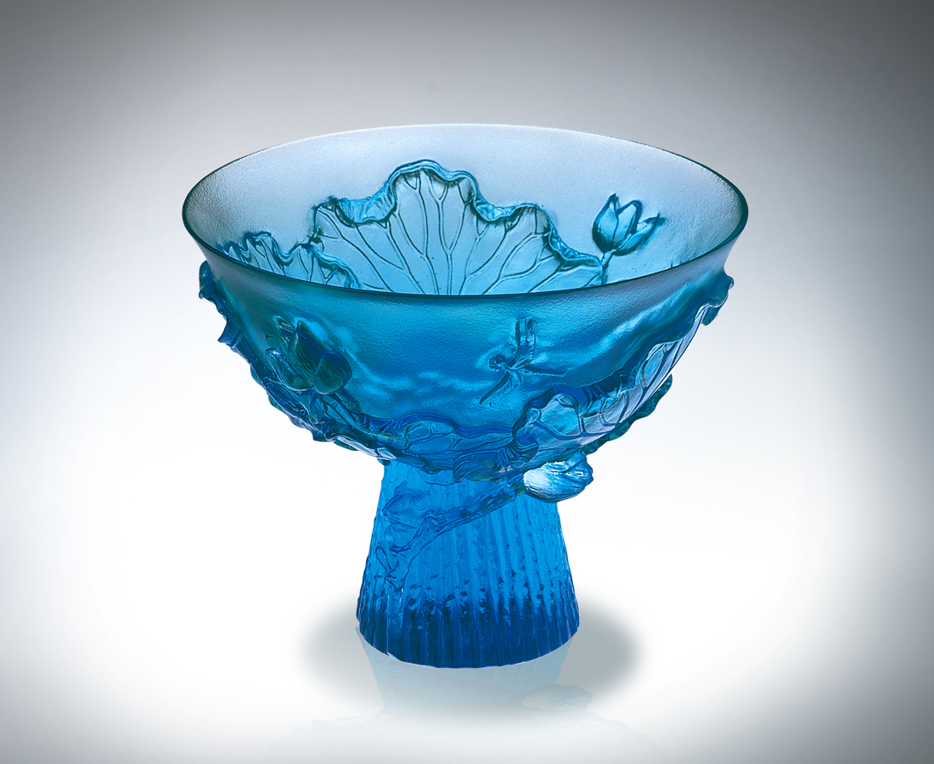
攤開片片緊繃的牽絆
向無邊空間隨興舒展
左右渲染 開懷有勁
拔高根根深植的糾纏
向自我天空爭先投入
上下簇擁 真誠有情
斟一口優雅的荷風醉意
圓融勝境 好夢成真
Satisfactory
Casting off so many trammels Extending infinitely at great ease Developing in all directions with vigor Getting rid of deep-rooted troubles Racing to throw ourselves into the sky Enjoying sincerity and emotions all around Savoring elegant breeze and intoxication Bringing a nice dream into reality and perfection

編號 | 1400111 | No | 1400111
名稱 | 心圓意滿 | Name | Satisfactory
顏色 | 青 | Color | cyan
尺寸 | 7.4*7.4*5.8 | Size | 7.4*7.4*5.8
重量 | 0.12 | Weight | 0.12
限量 | X | Limited Edition | X
售價 | NT$ 3360 | Price | NT$ 3360
 | RMB$ 788 |  | RMB$ 788

