秋蘭自信 | 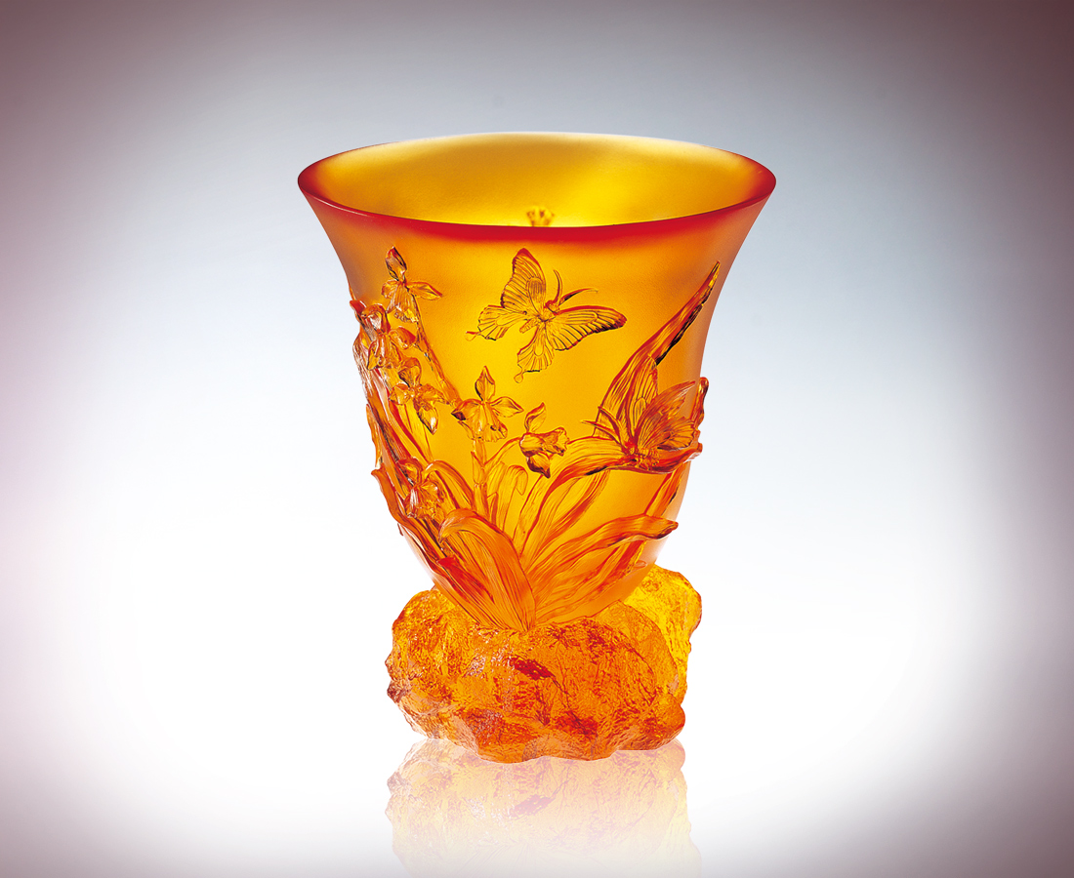
紛飛是歡愉的涼意
承載著飽滿的自信
搖曳有膠著的試探
擺動那蠱惑的企圖
忽左忽右 聲東擊西
秋天是一種策略
藉固若磐石的根基
隨風追捕心曠神怡的機運
Confidence of the Autumn Orchid
Swarming flight cools one’s joy; And carries complete confidence; Proffering sticky explorations And waving those bewitching ambitions; Suddenly right, suddenly left; feinting east and charging west; Autumn is a kind of strategy: Relying on a foundation as solid as a boulder Ride the wind and catch an uplifting moment.

編號 | 1400050 | No | 1400050
名稱 | 秋蘭自信 | Name | Confidence of the Autumn Orchid
顏色 | 琥／金紅 | Color | amber／golden, red
尺寸 | 15 * 15 * 17.5 | Size | 15 * 15 * 17.5
重量 | 2.15 | Weight | 2.15
限量 | X | Limited Edition | X
售價 | NT$ 19200 | Price | NT$ 19200
 | RMB$ 5288 |  | RMB$ 5288

