新生 | 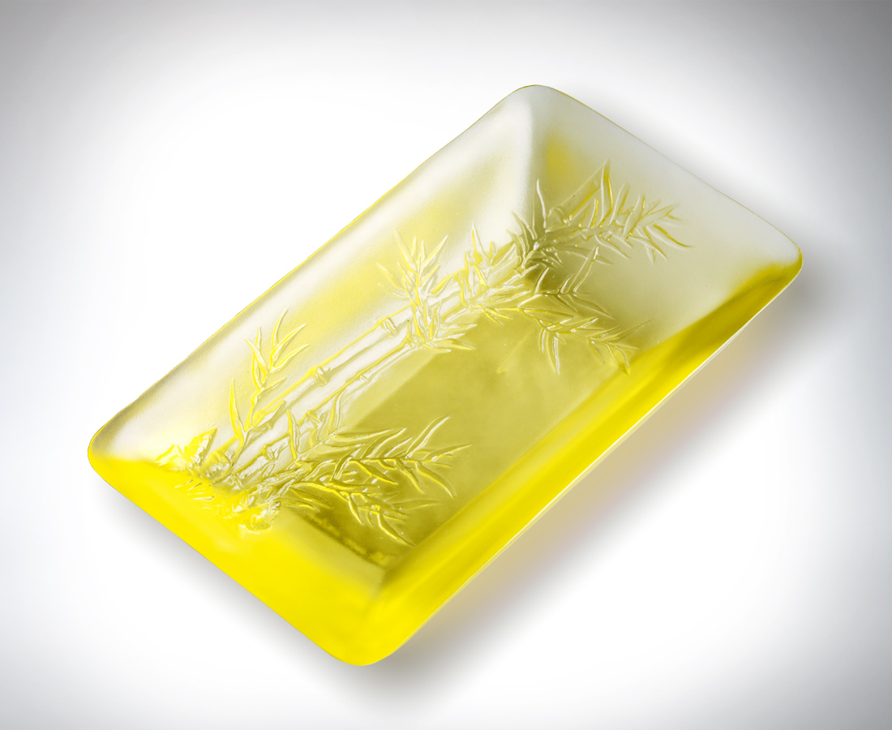
高聳參天的身影
迎風婆娑的新枝
新筍 抬頭仰望
也歸劃自己未來的藍圖
心中充滿期待和嚮往
在一步步升高 蛻變的過程
要經過挫折和失意
也要擁抱歡愉和成功
生命是義無反顧的成長
新生是無限的可能
New Birth
A silhouette standing tall and erect reaching for the sky A new branch facing the wind A new bamboo shoot lifts its head and looks up It measures its future with a heart full of hope and expectation Step by step and a qualitative change Set backs and disappointments must be experienced. But happiness, and maturity must also be embraced Life is growth that allows no turning back New life is limitless possibilities

編號 | 1314035 | No | 1314035
名稱 | 新生 | Name | New Birth
顏色 | 金 | Color | golden
尺寸 | 18.7 * 11 * 4.5 | Size | 18.7 * 11 * 4.5
重量 | 0.85 | Weight | 0.85
限量 | O | Limited Edition | O
售價 | NT$ 6880 | Price | NT$ 6880
 | RMB$ 1530 |  | RMB$ 1530

