隨緣 | 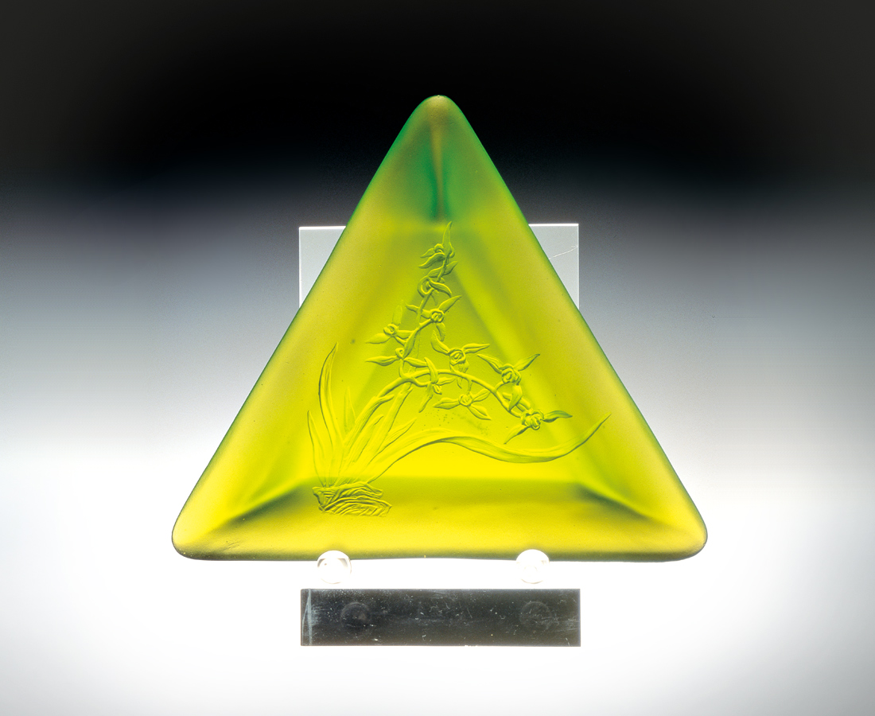
這個美 來自沒骨的柔順
和諧蘊藏洞悉世事的智慧
蘭花
將自然的抗爭視為福份而順受
在借力使力中展現無比的優柔
它迎向陽光 順著柔風
隨意也隨興地奔放自己
與世無爭 無欲而剛
蘭花 珍惜每個不經意的接觸
它 隨緣
To Follow Destiny
This meek beauty without bones In this harmoniousness there is a store of clear wisdom on human affairs. The orchid will naturally resist the existence of good fortune and yet easily accept In the borrowing and using of power none can compare to the orchid It faces the sun and moves with the wind At will it is bold, unrestrained and at ease No conflict with the world, no desire yet firm Every contact with the orchid is precious It follows destiny

編號 | 1314027 | No | 1314027
名稱 | 隨緣 | Name | To Follow Destiny
顏色 | 綠 | Color | green
尺寸 | 16 * 17.3 * 4 | Size | 16 * 17.3 * 4
重量 | 0.5 | Weight | 0.5
限量 | O | Limited Edition | O
售價 | NT$ 6880 | Price | NT$ 6880
 | RMB$ 1530 |  | RMB$ 1530

