如意荷諧 | 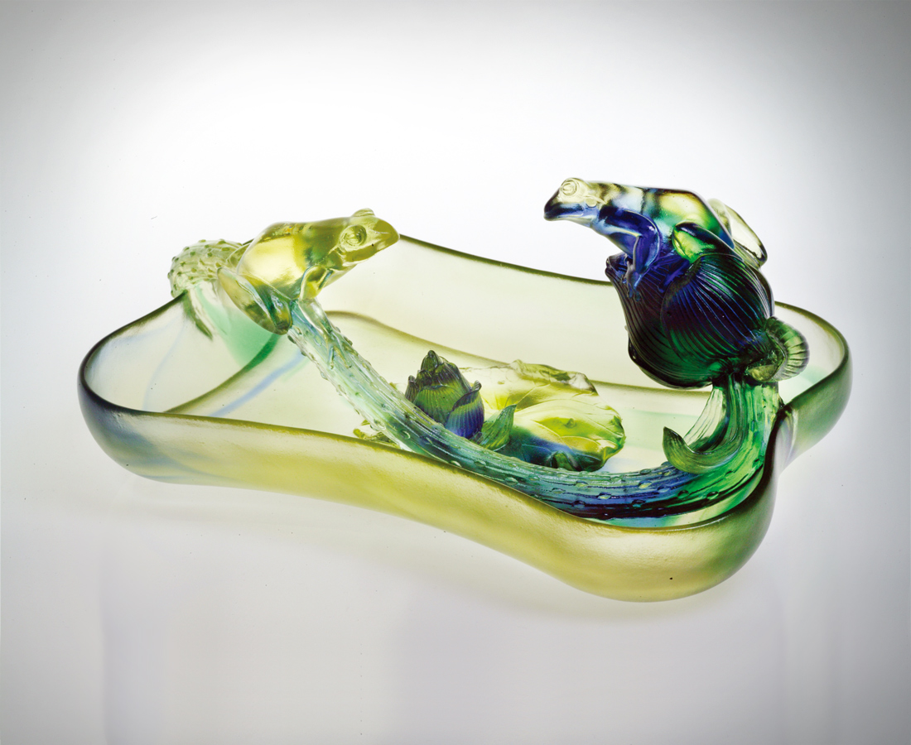
意見也許不同
步調或有快慢
但換個立場設身處地
就有先來後到的尊重
就有你說我聽的共鳴
同中求異有創意
異中求同有和諧
交響各施所長的合作
共結因緣合荷的如意
Living in Harmony
We may have differences in opinion Or live our lives with a different pace But imagine a change of perspective Where precedence commands respect Where responses are sought and heard Innovation is motivated by the search to be different Harmony results from the search for commonality Leveraging the core competences of each person in collaboration Exuding the joyous fulfillment of a perfect match

編號 | 1312202 | No | 1312202
名稱 | 如意荷諧 | Name | Living in Harmony
顏色 | 金綠紅 | Color | golden, green, red
尺寸 | 14.8 * 22 * 10 | Size | 14.8 * 22 * 10
重量 | 1.3 | Weight | 1.3
限量 | O | Limited Edition | O
售價 | NT$ 17880 | Price | NT$ 17880
 | RMB$ 4466 |  | RMB$ 4466

