一片清馨 | 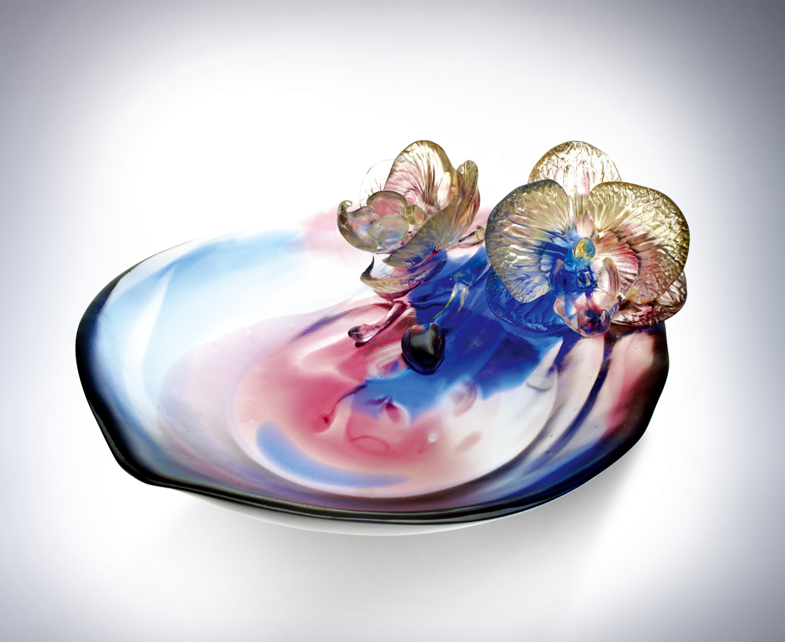
世界形色紛擾
心中一片清淨
靜心屏氣 放心吐納
感知四時節氣的脈動
聽見生命奔放的樂章
隨風 延展擴散
隨氣 一片坦然
花開與蝶漫舞
心開與人共舞
隨喜自在 一片清新
A Breath of Fresh Air
In the turmoil of today’s world With a serene calm in the heart With a calm composure, breathe without reservation Sensing the intriguing changes of the four seasons Hearing the joyous music of unconstrained living Follow the wind and reach far beyond Follow the sweet air and savor the boundless honesty Butterflies dancing amongst the blooming flowers Dancing merrily Be mirthful and enjoy a breath of fresh air

編號 | 1312179 | No | 1312179
名稱 | 一片清馨 | Name | A Breath of Fresh Air
顏色 | 金藍紫透 / 金藍紫透(粒料) | Color | golden, blue, purple, clear
尺寸 | 18 * 22.7 * 8 | Size | 18 * 22.7 * 8
重量 | 1.5 | Weight | 1.5
限量 | O | Limited Edition | O
售價 | NT$ 13800 | Price | NT$ 13800
 | RMB$ 3466 |  | RMB$ 3466

