如意長青 | 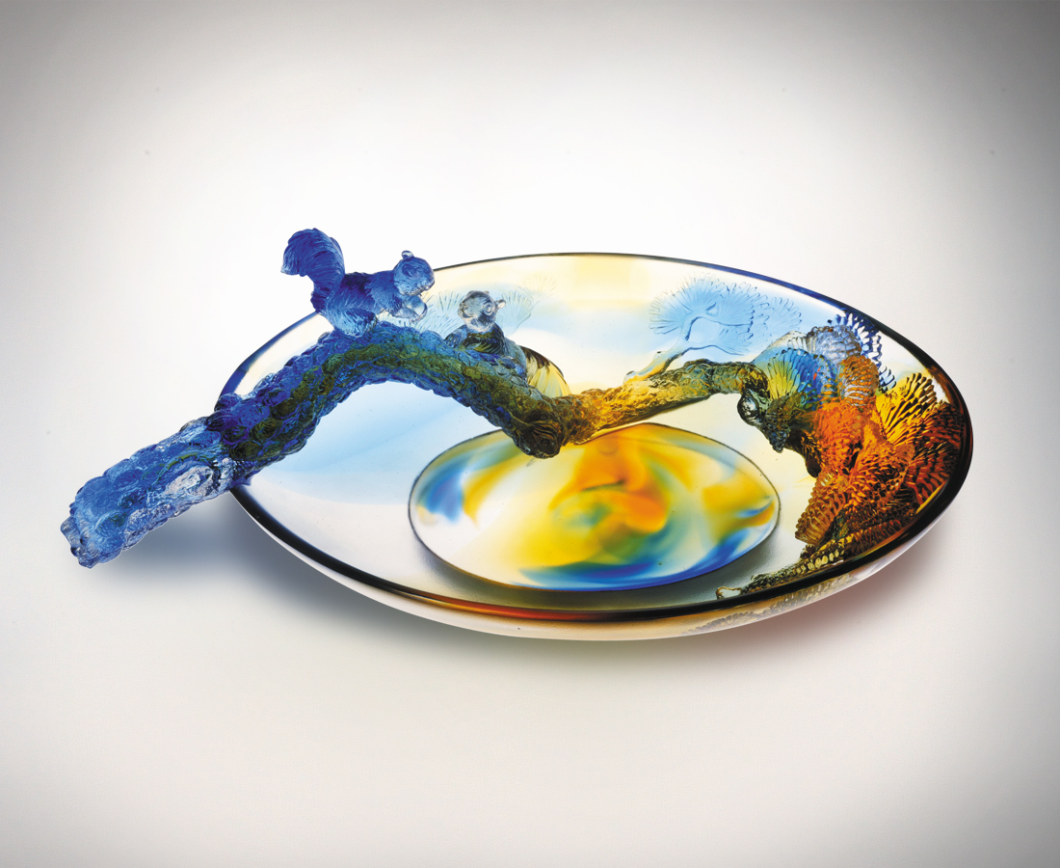
跳上跑下 沒有設限
穿梭推陳出新的歡喜
奔前竄後 不忮不求
悠遊豁朗愉悅的身心
換個角度 調個視焦
如松隨風展開的自在
擺盪隨遇而安的開闊
便有隨喜的福份 而
樹常青人常好事如意
Good Fortune Always
Jumping high and low without restraint Throwing out the old and welcoming the new Leaping forward with purpose and direction With a carefree and optimistic heart Adapting to change, taking a different perspective Like the pine tree swaying freely with the wind Welcoming any challenges head on with open arms generating unending happiness and fortune May we, like the evergreen tree, be blessed with good fortune always

編號 | 1312174 | No | 1312174
名稱 | 如意長青 | Name | Good Fortune Always
顏色 | 藍琥透 | Color | blue, amber, clear
尺寸 | 16.8 * 27.3 * 8.8 | Size | 16.8 * 27.3 * 8.8
重量 | 1.24 | Weight | 1.24
限量 | O | Limited Edition | O
售價 | NT$ 17800 | Price | NT$ 17800
 | RMB$ 4466 |  | RMB$ 4466

