如意愉悅 | 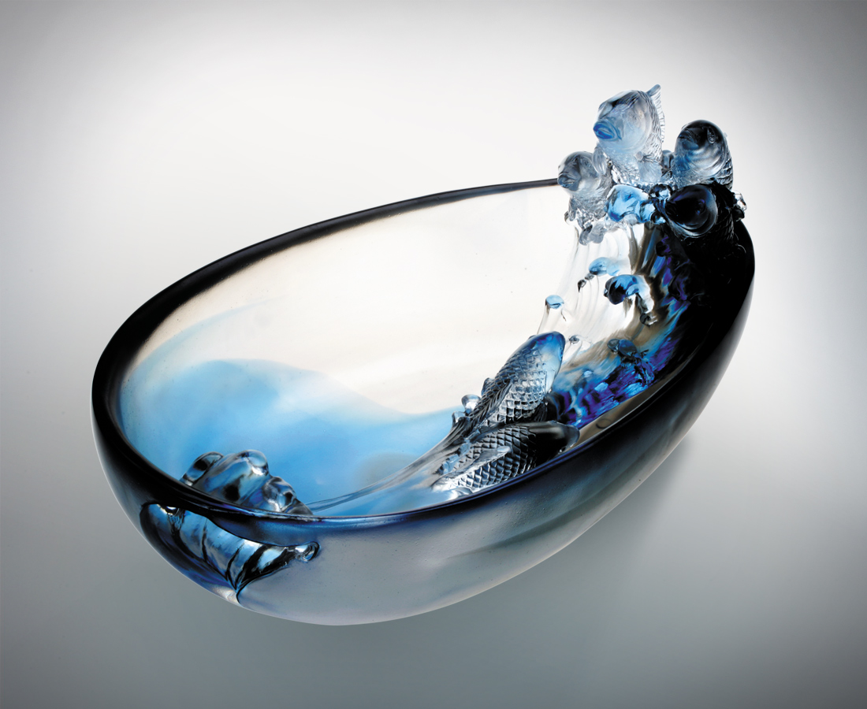
時享如魚得水的潛泳
時興乘風破浪的歡躍
高唱低吟 各有美妙
悠遊自得 永遠激盪
招來魚躍共樂的好緣
集聚年年有餘的好運
一圓這情節高潮迭起
如意愉悅的生命軌跡
Pleasant Delight
Frolicking freely in the waters like a fish Relishing in the joy of rising to the challenges Singing at the top of our voices or softly humming, to each its own Carefree and relaxed, always filled with passion and conviction Seize every opportunity that swims your way Accumulate good fortune wherever you go Let this high tide of goodness show up The good tidings and delights of life

編號 | 1312167 | No | 1312167
名稱 | 如意愉悅 | Name | Pleasant Delight
顏色 | 青灰透 | Color | cyan, gray, clear
尺寸 | 17 * 28 * 13.9 | Size | 17 * 28 * 13.9
重量 | 5.5 | Weight | 5.5
限量 | O | Limited Edition | O
售價 | NT$ 21680 | Price | NT$ 21680
 | RMB$ 5422 |  | RMB$ 5422

