無我 | 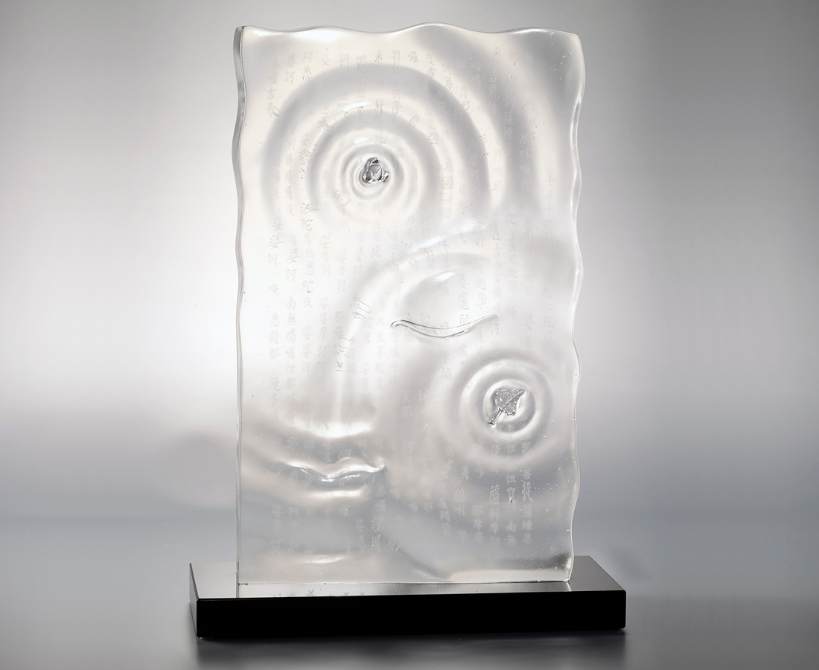
心淨覺無我
水流花自開
Buddha’s Smile
Lotus blooms and linden leaves make ripples in the water to form Buddha’s smile. The intertwining of myth and fact represents that Dharma is ubiquitous.

編號 | 1293800 | No | 1293800
名稱 | 無我 | Name | Buddha’s Smile
顏色 | 透 + K9底座 | Color | clear + K9
尺寸 | 22 * 9.5 * 30.2 | Size | 22 * 9.5 * 30.2
重量 | 6.9 | Weight | 6.9
限量 | O | Limited Edition | O
售價 | NT$ 33680 | Price | NT$ 33680
 | RMB$ 7500 |  | RMB$ 7500

