輕拈幸福 | 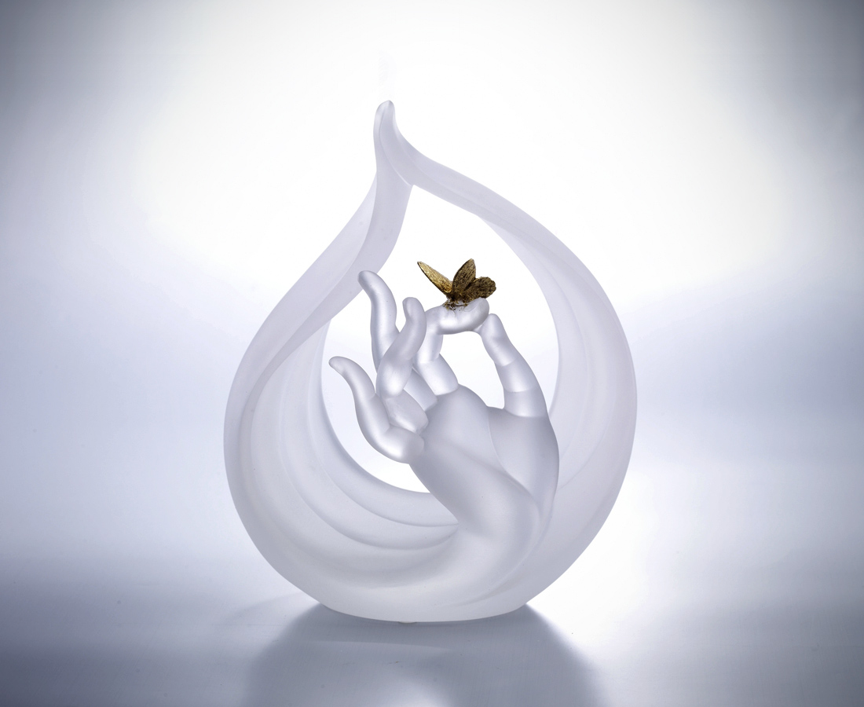
身形如水 心境無礙
拈起微笑 日日好日

Achieving True Happiness
This artwork is shaped like the hand of the preaching Buddha. It signifies abandonment of prejudices and obsessions. The water droplet in the background symbolizes that people could have a humble and open mind to listen to others and to live happily and positively every day.

編號 | 1293291 | No | 1293291
名稱 | 輕拈幸福 | Name | Achieving True Happiness
顏色 | 透+金箔 | Color | clear
尺寸 | 10.7 * 15 * 18.2 | Size | 10.7 * 15 * 18.2
重量 | 1.6 | Weight | 1.6
限量 | X | Limited Edition | X
售價 | NT$ 12750 | Price | NT$ 12750
 | RMB$ 2830 |  | RMB$ 2830

