常樂 | 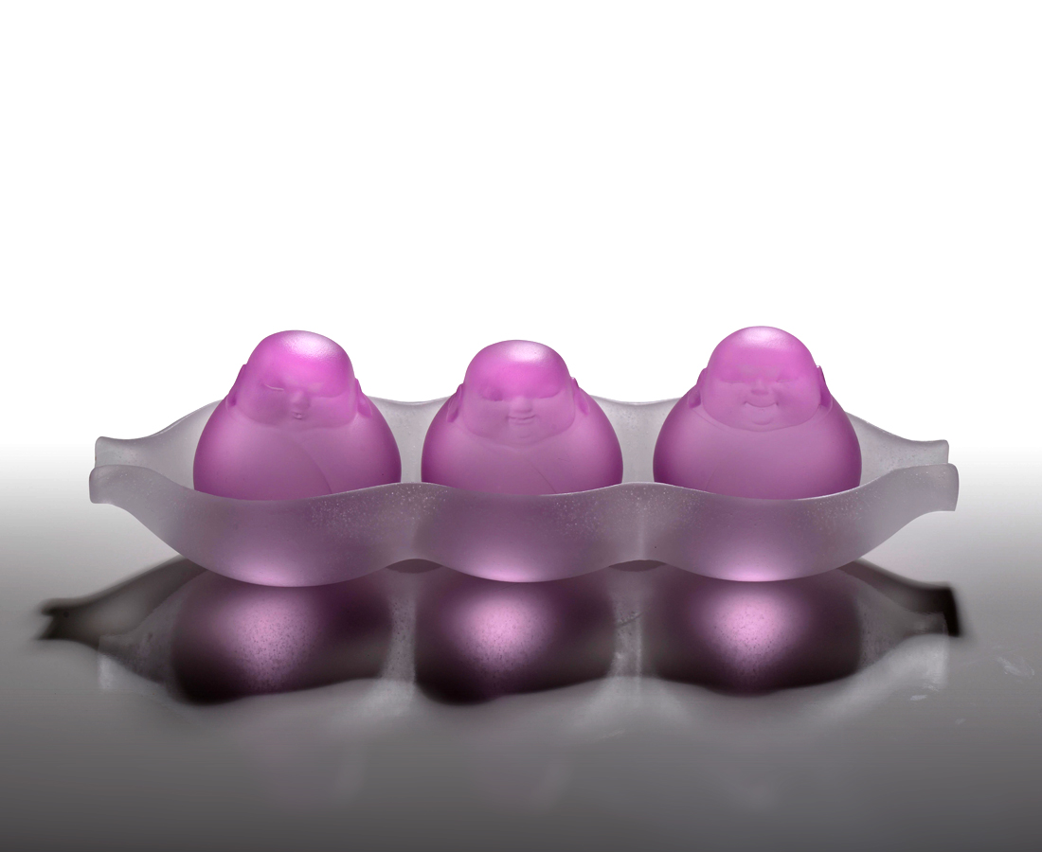
知足
是不分先後的快樂
Childlike Heart
You may put the three monks with different expression freely in different position of the pod like going back to the innocent time of playing toys in childhood.

編號 | 1253659 | No | 1253659
名稱 | 常樂 | Name | Childlike Heart
顏色 | 粉＋透 | Color | pink, clear
尺寸 | 24.5 * 8.1 * 7.5 | Size | 24.5 * 8.1 * 7.5
重量 | 1.2 | Weight | 1.2
限量 | X | Limited Edition | X
售價 | NT$ 9980 | Price | NT$ 9980
 | RMB$ 2220 |  | RMB$ 2220

