歡喜人間 | 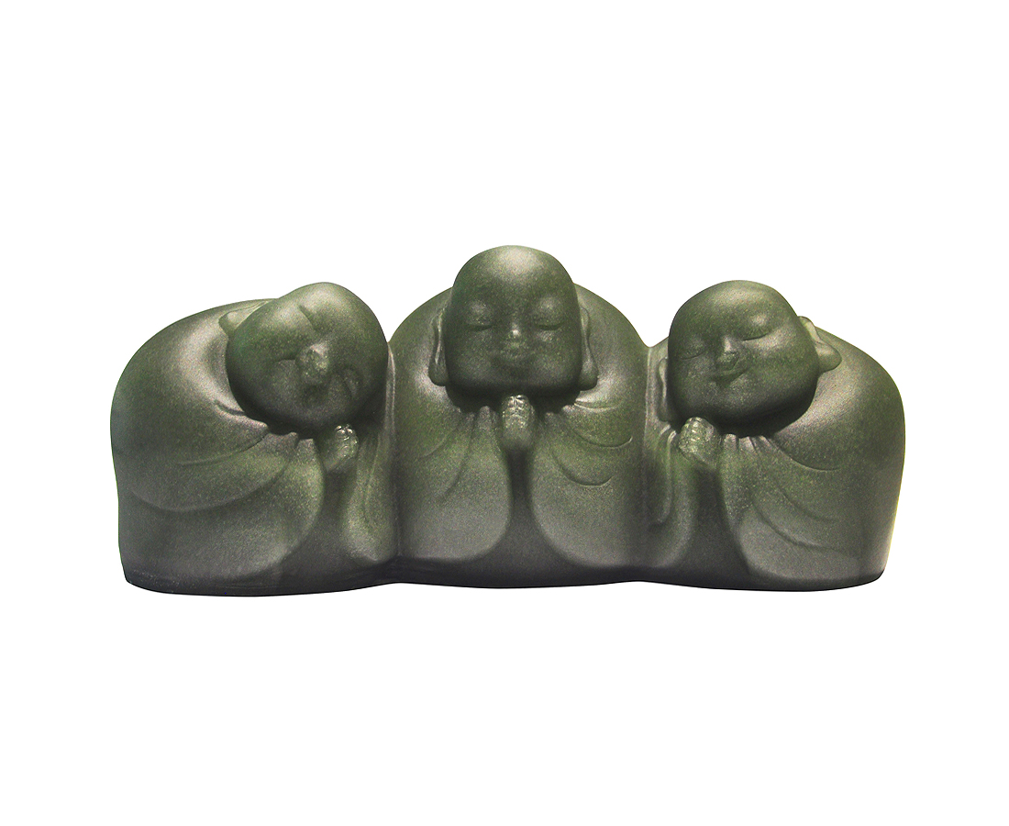
人間好遊戲
歡喜在人間
No Sorrows; No Worries; No Covetousness
The three smiling monks seem to tell us that we can happily spend each day as soon as we take "no sorrows; no worries; no covetousness" attitude toward life.

編號 | 1253658 | No | 1253658
名稱 | 歡喜人間 | Name | No Sorrows; No Worries; No Covetousness
顏色 | 灰透 | Color | gray, clear
尺寸 | 20.1 * 7.3 * 8.2 | Size | 20.1 * 7.3 * 8.2
重量 | 1.95 | Weight | 1.95
限量 | X | Limited Edition | X
售價 | NT$ 9680 | Price | NT$ 9680
 | RMB$ 2150 |  | RMB$ 2150

