洞見 | 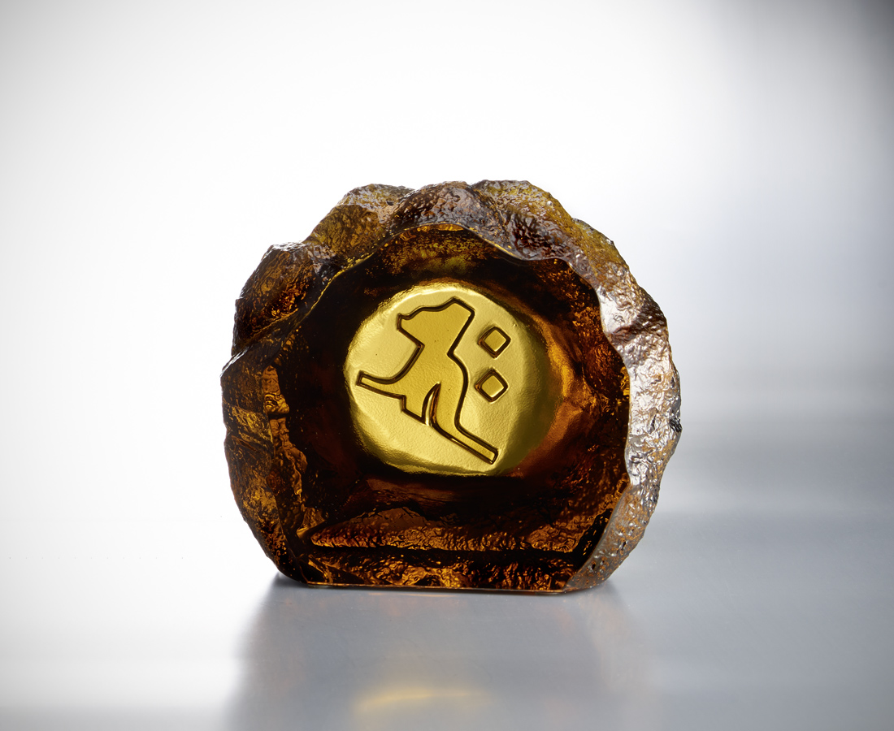
朝朝勤拂拭
磨石能成鏡
立地可成佛
The seed character of Buddhism
In Buddhism, the seed character is a special design that is beneficial to transmission. Every seed character represents a Buddha and a type of spirit. This Tittot design from the seed character represents Buddha Shakya Muni in rocks. Through the pure polishing surface, a devote attitude of life is delivered.

編號 | 1253576 | No | 1253576
名稱 | 洞見 | Name | The seed character of Buddhism
顏色 | 茶 | Color | brown
尺寸 | 12.8 * 6 * 10 | Size | 12.8 * 6 * 10
重量 | 1.3 | Weight | 1.3
限量 | X | Limited Edition | X
售價 | NT$ 3980 | Price | NT$ 3980
 | RMB$ 890 |  | RMB$ 890

