種子 | 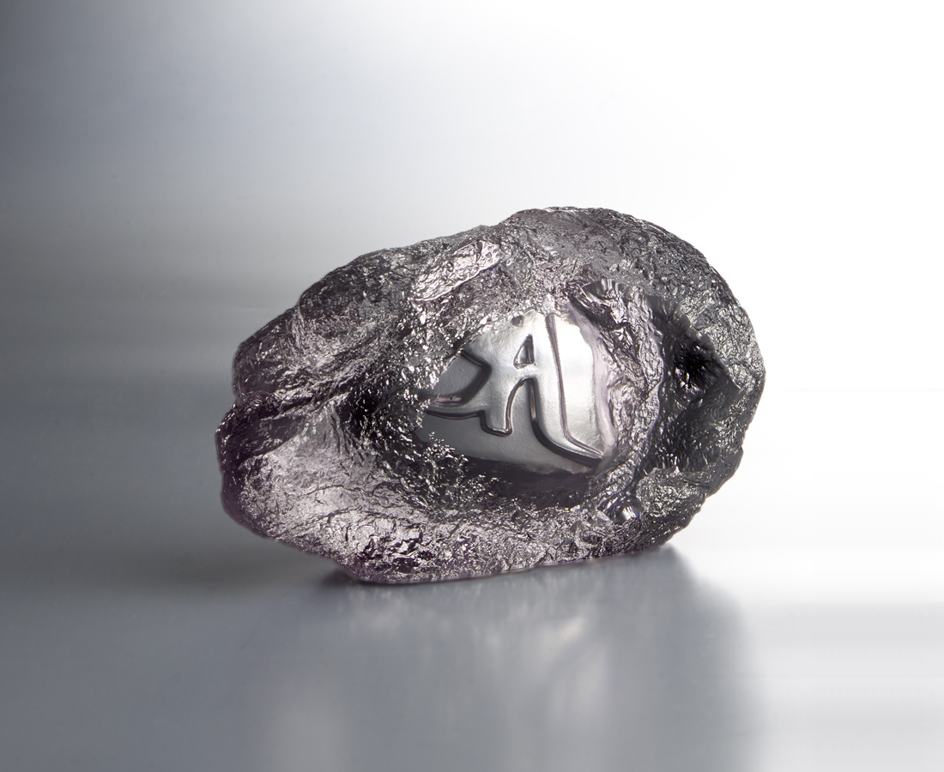
一顆種子
讓岩石成沃土
一個意念
讓心生出自在
The seed character of Guanyin (Goddess of Mercy)
In Buddhism, the seed character is a special design that is beneficial to transmission. Every seed character represents a Buddha and a type of spirit. The Tittot design from the seed character represents Guanyin in rocks. Through the pure polishing surface, a devote attitude of life is delivered.

編號 | 1253575 | No | 1253575
名稱 | 種子 | Name | The seed character of Guanyin (Goddess of Mercy)
顏色 | 灰 | Color | gray
尺寸 | 13 * 5 * 8 | Size | 13 * 5 * 8
重量 | 0.76 | Weight | 0.76
限量 | X | Limited Edition | X
售價 | NT$ 3260 | Price | NT$ 3260
 | RMB$ 730 |  | RMB$ 730

