大慧 | 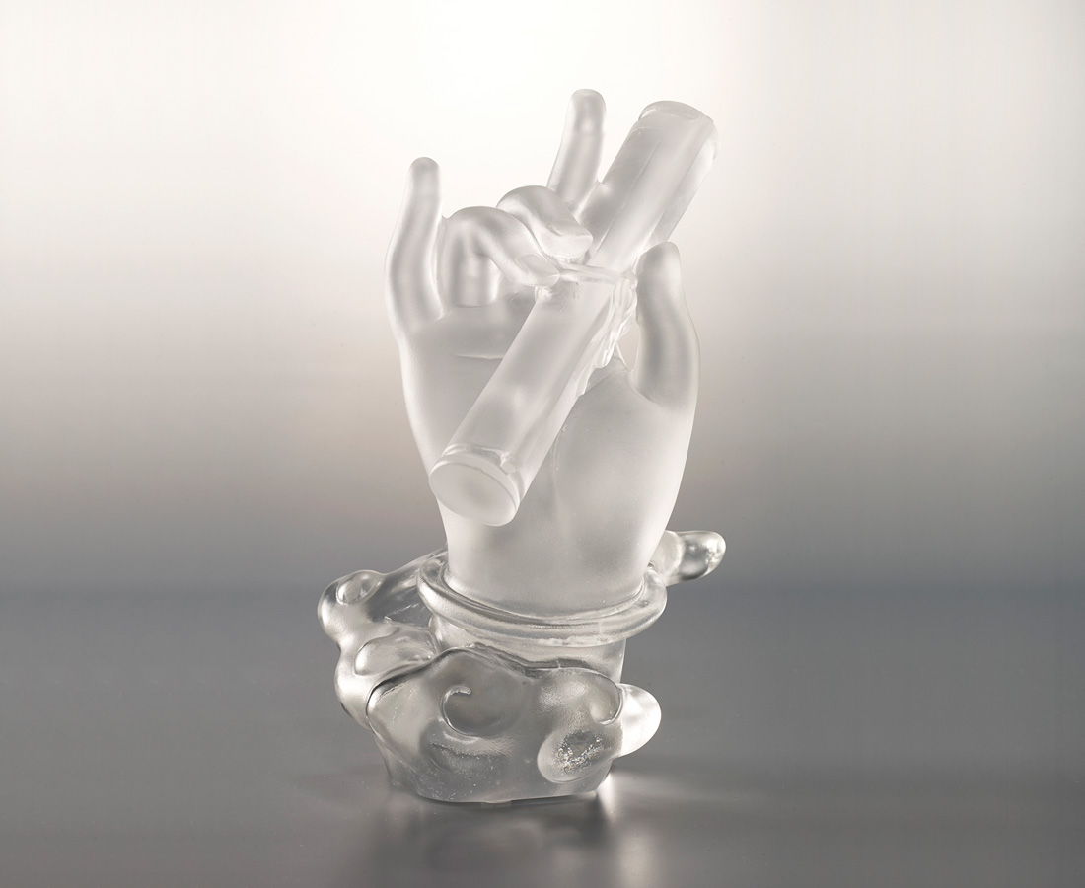
以慈為慧
解眾生苦
若為多聞廣學者
當於寶經手
The Hold of Buddhist Scripture
This sculpture is designed based on the incarnation of Guanyin from Buddhist Scriptures. The scripture means wisdom. Guanyin holding the scripture symbolizes passing on the wisdom to all creatures.

編號 | 1243795 | No | 1243795
名稱 | 大慧 | Name | The Hold of Buddhist Scripture
顏色 | 透 | Color | clear
尺寸 | 9 * 8.8 * 15.2 | Size | 9 * 8.8 * 15.2
重量 | 0.86 | Weight | 0.86
限量 | O | Limited Edition | O
售價 | NT$ 11600 | Price | NT$ 11600
 | RMB$ 2580 |  | RMB$ 2580

