大福 | 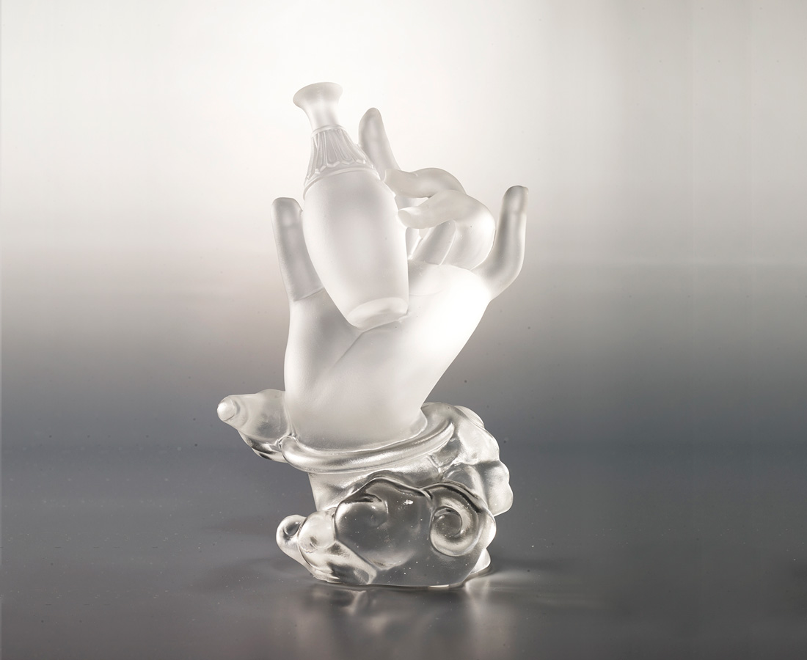
以空為福
滿眾生願
若為一切善和眷屬者
當於寶瓶手
The Hold of the Bottle
This sculpture is designed based on the incarnation of Guanyin from Buddhist Scriptures. As one of Guanyin’s instruments, the bottle keeps the harmony among people.

編號 | 1243794 | No | 1243794
名稱 | 大福 | Name | The Hold of the Bottle
顏色 | 透 | Color | clear
尺寸 | 9 * 7.9 * 15.6 | Size | 9 * 7.9 * 15.6
重量 | 0.87 | Weight | 0.87
限量 | O | Limited Edition | O
售價 | NT$ 11600 | Price | NT$ 11600
 | RMB$ 2580 |  | RMB$ 2580

