月常圓 | 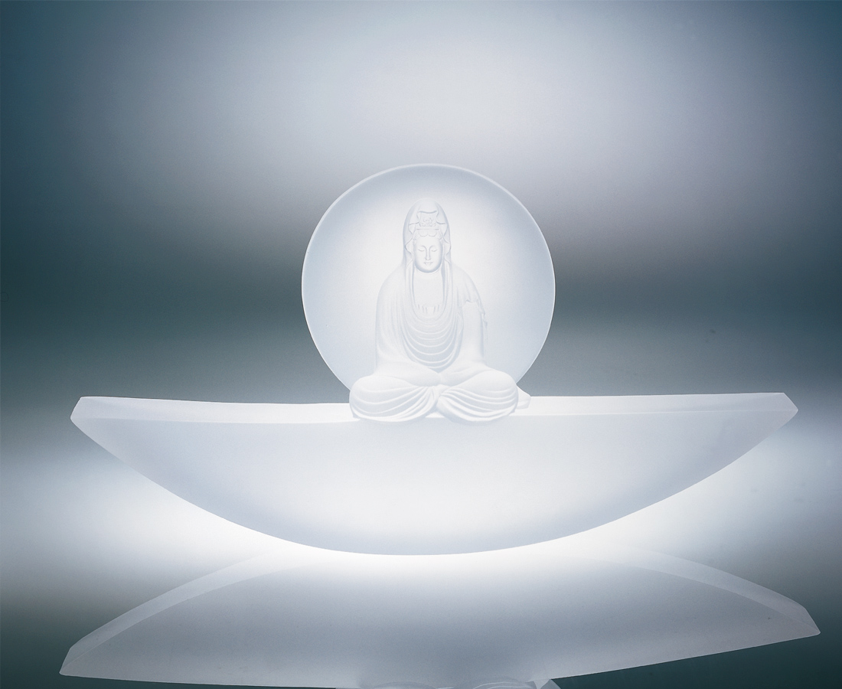
靜觀水月
月圓月殘
生命本無塵
庸人自擾之
靜思人生
無常平常
困阨如擺渡
終究如止水
Round Moon
Calmly gaze, the moon in the water, Full moon, crescent moon, Life originally is spotless, The common person harasses himself. Calmly consider, the life of a man, Variable, common, Hardships are a ferry, Eventually the water is still.

編號 | 1238071 | No | 1238071
名稱 | 月常圓 | Name | Round Moon
顏色 | 透 | Color | clear
尺寸 | 7 * 33.5 * 17.5 | Size | 7 * 33.5 * 17.5
重量 | 3.5 | Weight | 3.5
限量 | O | Limited Edition | O
售價 | NT$ 25100 | Price | NT$ 25100
 | RMB$ 6266 |  | RMB$ 6266

