如來 | 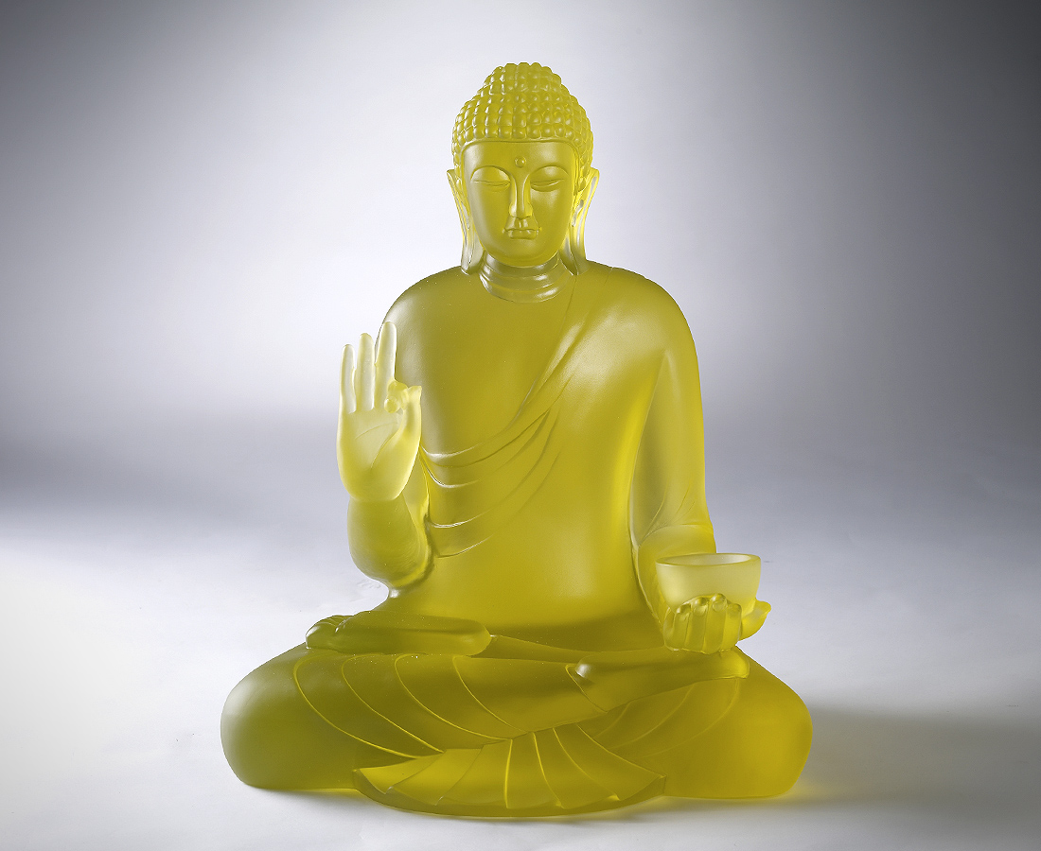
三藏十二部佛法
八萬四千個法門
Medicine Buddha Sutra
The Buddha statue with open arms is a welcoming symbol, indicating that everyone can find someone to lean on, to confide to and to faithfully adhere to.

編號 | 1236094 | No | 1236094
名稱 | 如來 | Name | Medicine Buddha Sutra
顏色 | 金 | Color | Golden
尺寸 | 37.5 * 44 * 50 | Size | 37.5 * 44 * 50
重量 | 63.0 | Weight | 63.0
限量 | O | Limited Edition | O
售價 | NT$ 536800 | Price | NT$ 536800
 | RMB$ 113500 |  | RMB$ 113500

