覺喜樂 | 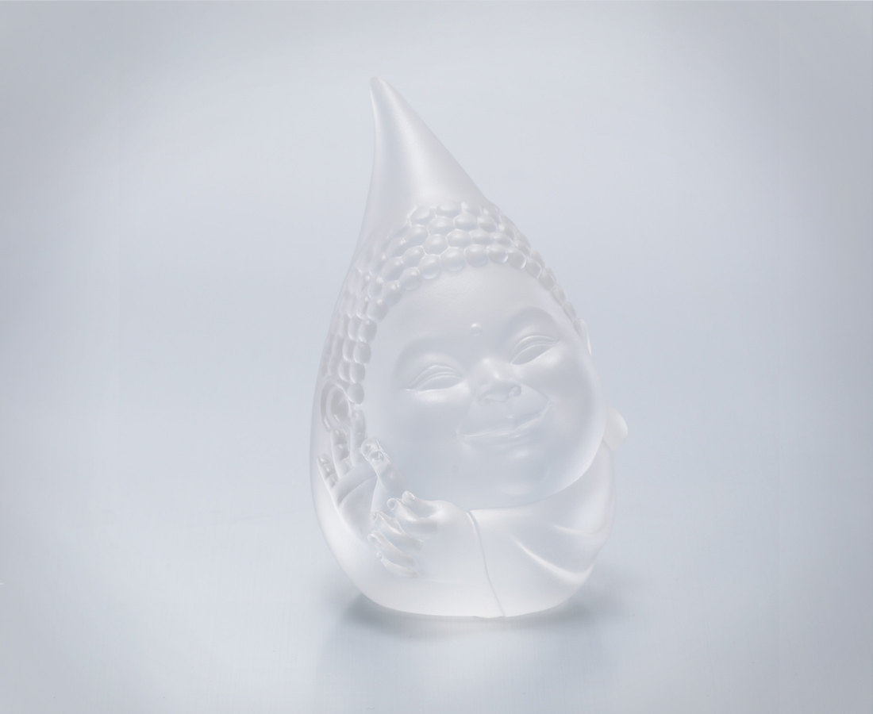
晨醒即微笑
過好每一刻
天天是好日
Realization of Happiness
Smiling while awakening in the morning Diligently live through every moment Each day is a wonderful day

編號 | 1232994 | No | 1232994
名稱 | 覺喜樂 | Name | Realization of Happiness
顏色 | 透(噴砂) | Color | clear (sand blasting)
尺寸 | 7 * 7.2 * 12.3 | Size | 7 * 7.2 * 12.3
重量 | 0.7 | Weight | 0.7
限量 | X | Limited Edition | X
售價 | NT$ 4680 | Price | NT$ 4680
 | RMB$ 1020 |  | RMB$ 1020

