心境轉 | 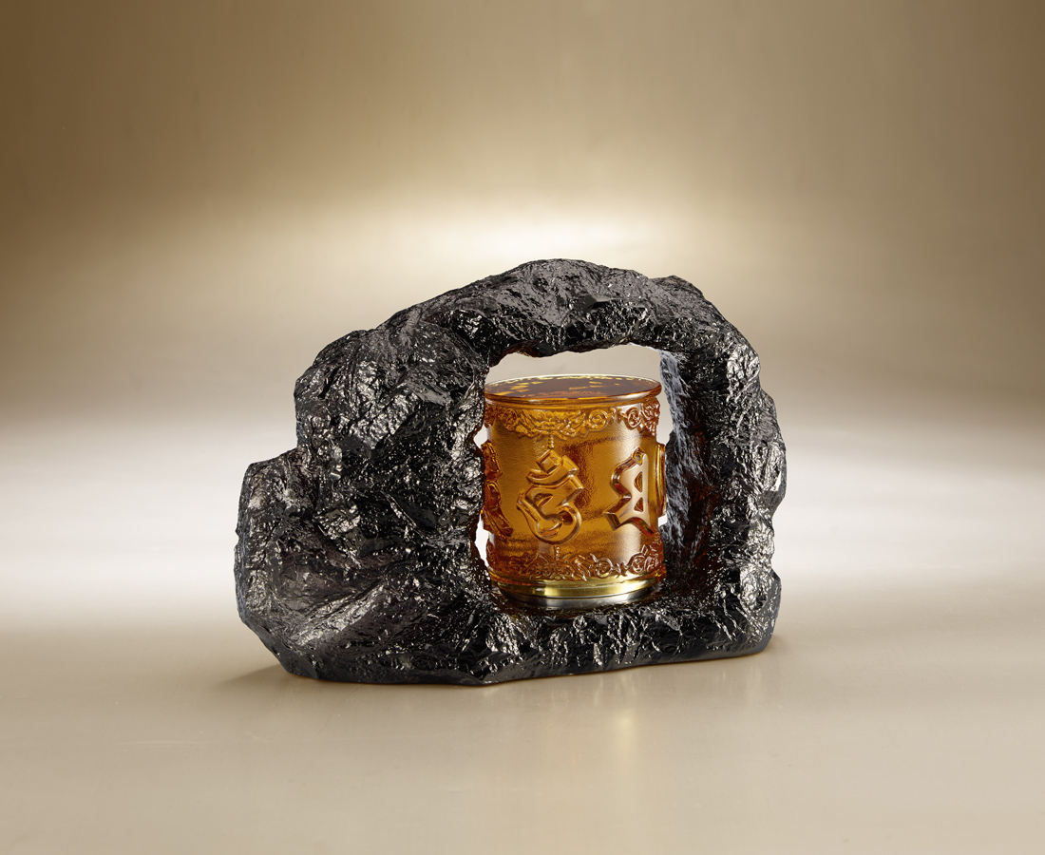
轉起智慧
轉動慈悲
心轉 境亦轉
Prayer wheels
Tittot transforms the traditional Buddist prayer wheels into desk ornaments. The spinning wheel with the Six Character of Buddhism Scripture will turn around and around, which make people calm down.

編號 | 1223580 | No | 1223580
名稱 | 心境轉 | Name | Prayer wheels
顏色 | 琥灰＋金屬 | Color | amber , gray ＋ metal
尺寸 | 19 * 7.7 * 14 | Size | 19 * 7.7 * 14
重量 | 3.0 | Weight | 3.0
限量 | X | Limited Edition | X
售價 | NT$ 9880 | Price | NT$ 9880
 | RMB$ 2200 |  | RMB$ 2200

