淨觀 | 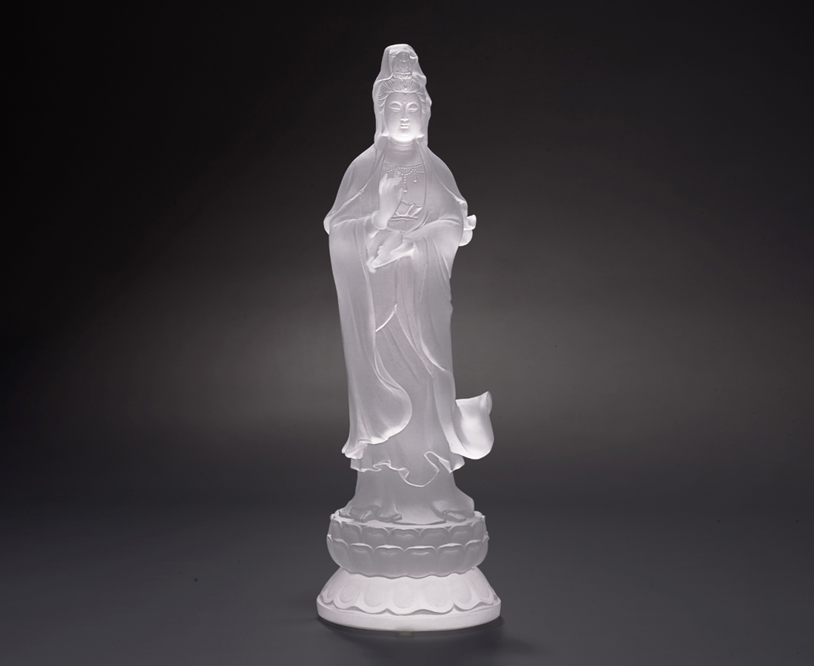
法雨垂空 匯得淨池
洗俗滌塵 眾生蒙薰
樂以受道 謙以反躬
菩提下種 功德成林
Goddess Kuan Yin and the Spring of Life
Kuan Yin is one of the most famous Buddhist deities and is revered for her compassionate approach to the suffering of sentient beings, and is worshipped in almost all Buddhist temples. Kuan Yin often holds her own sacred vessel, the Vase of Life, which is said to have an infinite capacity and can easily quench fires and resurrect lives, thus symbolizing the blessing of all beings.

編號 | 1214089 | No | 1214089
名稱 | 淨觀 | Name | Goddess Kuan Yin and the Spring of Life
顏色 | 透 | Color | clear
尺寸 | 7.9 * 7.6 * 24.55 | Size | 7.9 * 7.6 * 24.55
重量 | 1.14 | Weight | 1.14
限量 | O | Limited Edition | O
售價 | NT$ 14800 | Price | NT$ 14800
 | RMB$ 3290 |  | RMB$ 3290

