慈容 | 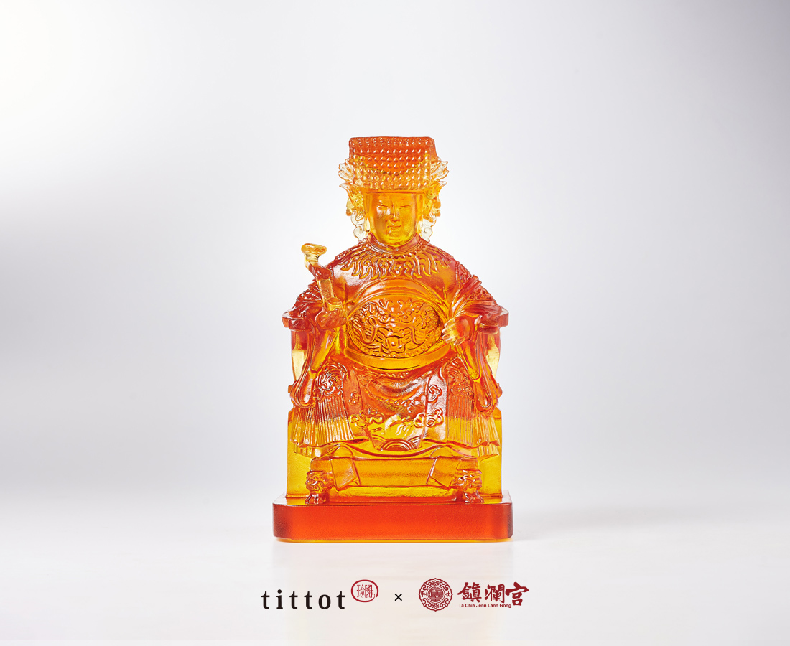
天照慈容聖
上應眾生母
大千端坐鎮
甲子永安瀾
The Loving Mazu
The project is a joint collaboration between tittot and the Dajia Jenn Lann Temple located in Taichung, a symbolic temple of the Mazu worship in Taiwan. Mazu is the most influential female goddess of the seas in the Chinese cultural sphere, along the coast of Southeast Asia. From the earliest days of blessing fishermen at sea to the widespread blessing of all beings, Mazu is the representation of the mother figure to the local people.

編號 | 1214088 | No | 1214088
名稱 | 慈容 | Name | The Loving Mazu
顏色 | 琥 | Color | mber
尺寸 | 5.7 * 7.1 * 12 | Size | 5.7 * 7.1 * 12
重量 | 0.59 | Weight | 0.59
限量 | O | Limited Edition | O
售價 | NT$ 4880 | Price | NT$ 4880
 | RMB$ 1090 |  | RMB$ 1090

