富貴好聲音 | 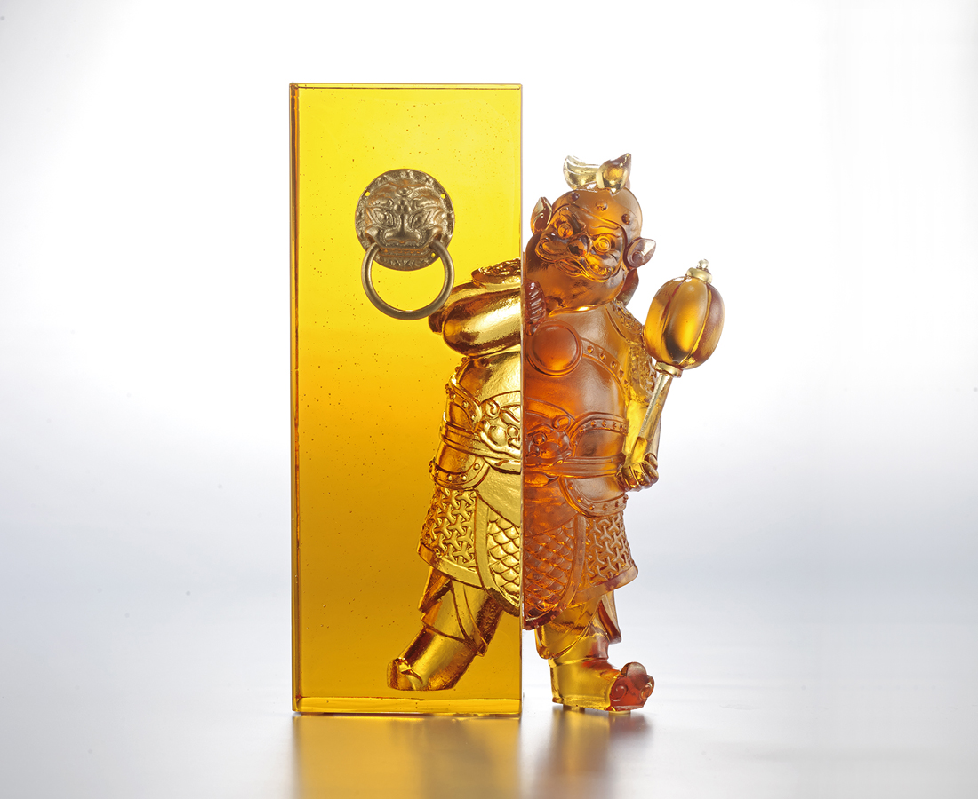
年年 貴氣敲門
日日 好運隨身
從今而後
富貴 盈門而入
Door God Warrior General
According to legend, Emperor Taizong (second emperor of China’s Tang Dynasty 618-907 AD), had two generals standing in front of the palace to protect him from harassment by demons and monsters in the night. Later, this gradually gave rise to the custom of pasting pictures of warrior generals on doorways at Chinese New Year to symbolize protection for the family all year round.

編號 | 1213821 | No | 1213821
名稱 | 富貴好聲音 | Name | Door God Warrior General
顏色 | 深琥淺琥 + 金 | Color | dark amber, clear amber＋gilding
尺寸 | 13 * 6.5 * 17.8 | Size | 13 * 6.5 * 17.8
重量 | 2.18 | Weight | 2.18
限量 | O | Limited Edition | O
售價 | NT$ 14900 | Price | NT$ 14900
 | RMB$ 3310 |  | RMB$ 3310

