滌心 | 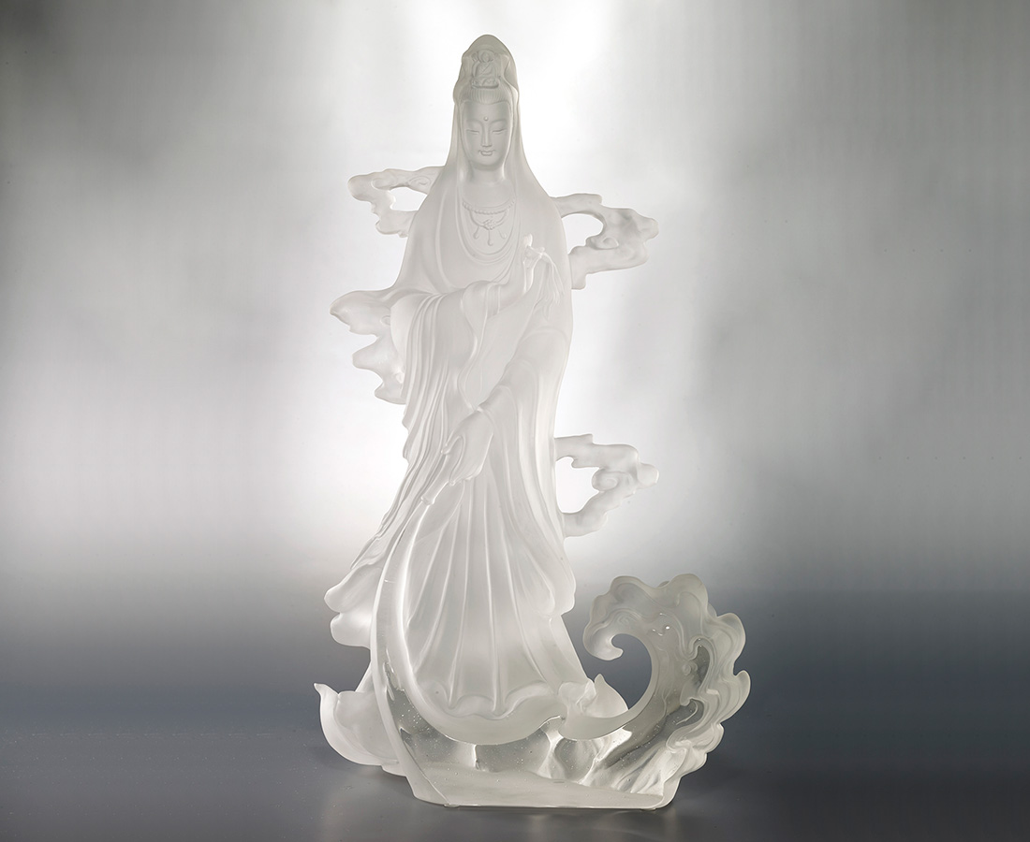
以清淨水
滌清靜心
瓶中甘露常時灑
手內楊柳不計秋
Manna Bottle Guanyin
Manna Bottle Guanyin is one of the incarnations of Guanyin, holding the bottle downward pouring out water to cleanse the pain and sufferings to comfort your heart.

編號 | 1213799 | No | 1213799
名稱 | 滌心 | Name | Manna Bottle Guanyin
顏色 | 透 | Color | clear
尺寸 | 25.7 * 17 * 42.2 | Size | 25.7 * 17 * 42.2
重量 | 9.32 | Weight | 9.32
限量 | O | Limited Edition | O
售價 | NT$ 108000 | Price | NT$ 108000
 | RMB$ 24000 |  | RMB$ 24000

