寂靜 | 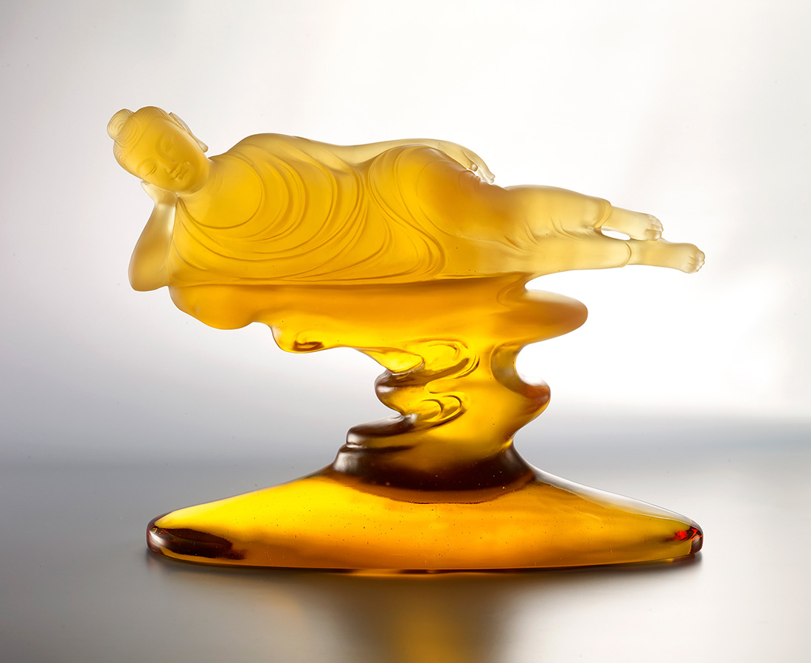
煩惱不現
寂靜清涼
Lying Buddha
Lying Buddha symbolizes the death of the body. Buddhism uses this Lying Buddha to convey the idea that all things disappear. Only by understanding this process can one not to be impacted by the pain death brings.

編號 | 1213798 | No | 1213798
名稱 | 寂靜 | Name | Lying Buddha
顏色 | 金 | Color | golden
尺寸 | 37 * 11.9 * 26.7 | Size | 37 * 11.9 * 26.7
重量 | 8.78 | Weight | 8.78
限量 | O | Limited Edition | O
售價 | NT$ 72800 | Price | NT$ 72800
 | RMB$ 16200 |  | RMB$ 16200

