清涼 | 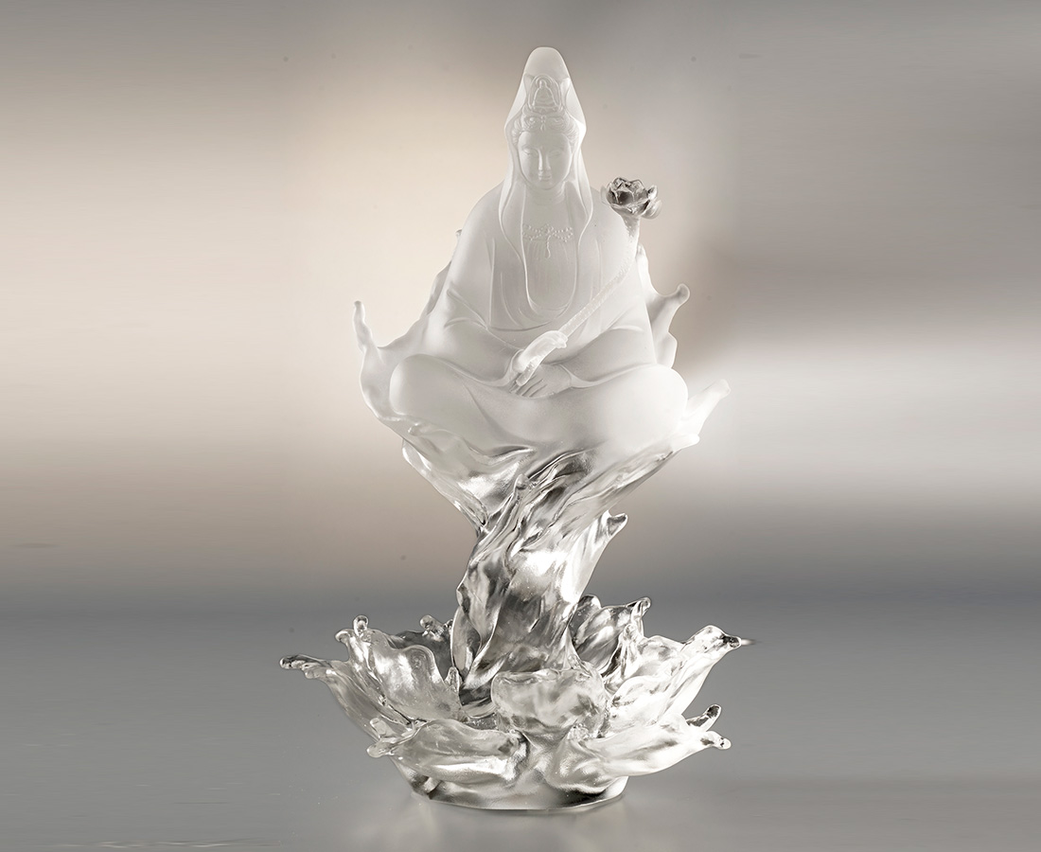
念彼觀音力
火坑變成池
Lotus Bloom Guanyin
The designers created the Guanyin sculpture with coagulated waves to express that Guanyin is everywhere when you have good will in mind.

編號 | 1213797 | No | 1213797
名稱 | 清涼 | Name | Lotus Bloom Guanyin
顏色 | 透 | Color | clear
尺寸 | 13.9 * 11.9 * 22.8 | Size | 13.9 * 11.9 * 22.8
重量 | 1.5 | Weight | 1.5
限量 | O | Limited Edition | O
售價 | NT$ 28680 | Price | NT$ 28680
 | RMB$ 6380 |  | RMB$ 6380

