忠義千秋 | 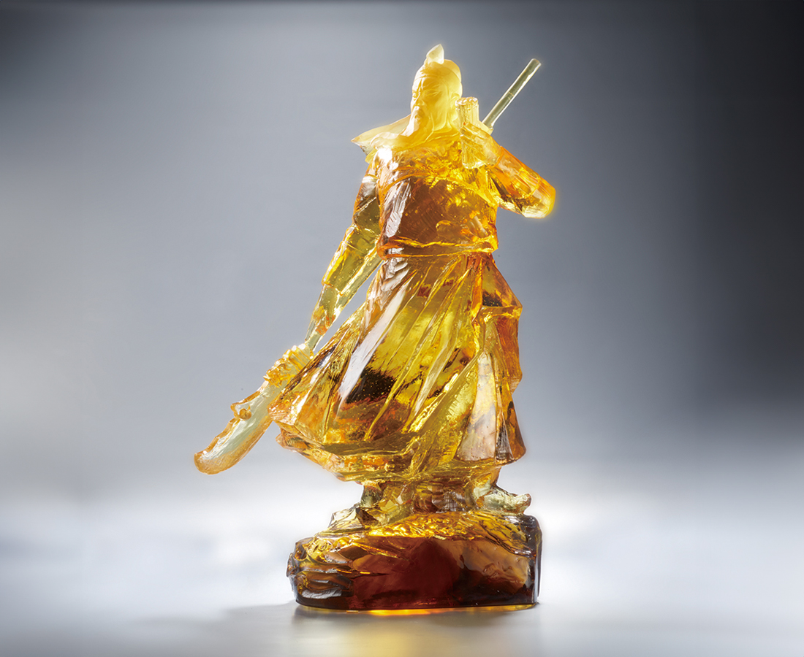
忠義千秋
春秋經 青龍刀
允文允武
過五關 震華夏
叱吒風雲
古往今來 千軍萬馬
惟有一片忠義
屹立千秋
Guan Yu
Tittot broke the impression of detail-oriented glass art and used the renowned “Lord Guan” in Chinese culture as the topic to present the heroic posture of General Guan Yu from the Three Kingdoms, utilizing rough techniques used in stone carving or wood carving.

編號 | 1213730 | No | 1213730
名稱 | 忠義千秋 | Name | Guan Yu
顏色 | 茶金＋金箔 | Color | brown, golden + gilding
尺寸 | 27.7 * 17.5 * 43.8 | Size | 27.7 * 17.5 * 43.8
重量 | 13.0 | Weight | 13.0
限量 | O | Limited Edition | O
售價 | NT$ 72500 | Price | NT$ 72500
 | RMB$ 16080 |  | RMB$ 16080

