慈悲行願 | 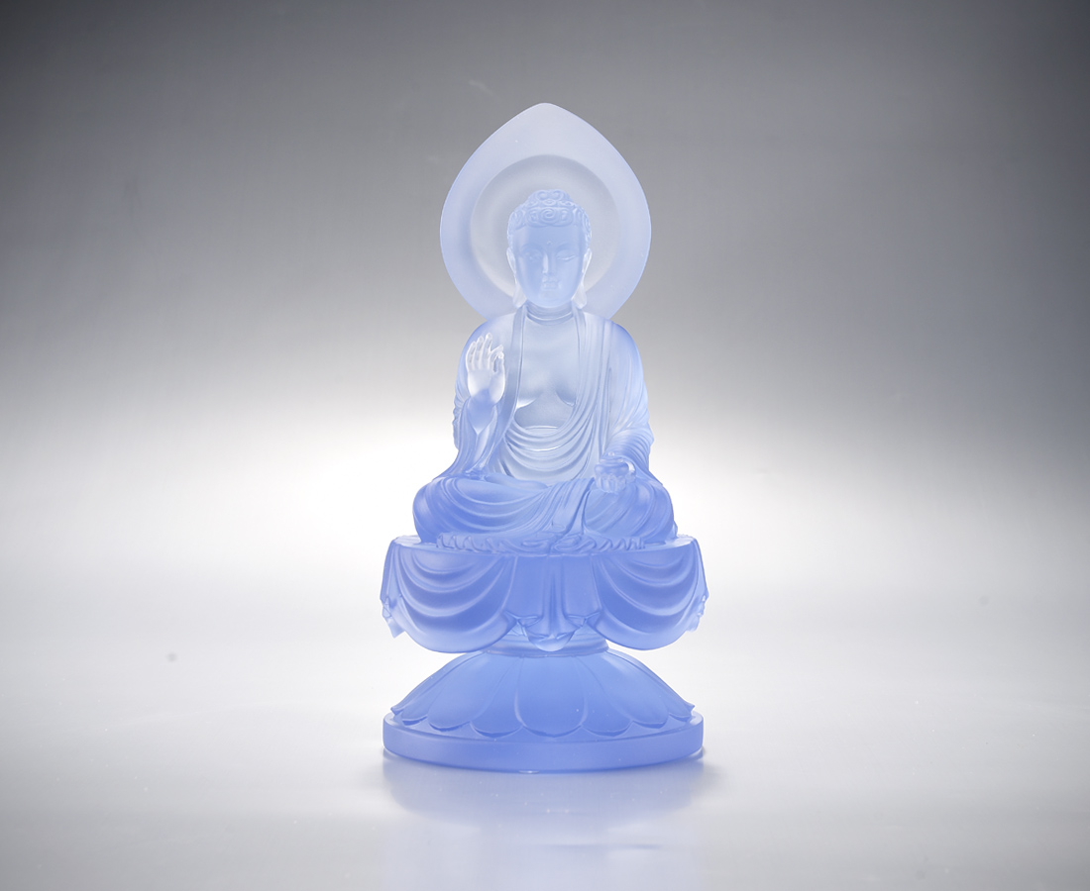
願眾生長壽無疾
願眾生衣食無缺
願眾生利益一切
Benevolent Practice
Bhaisajyaguru Buddha has determined upon 12 ultimate aspirations to relieve the world from pain and ufferings. He blesses the present life with bountiful livelihood, good health, auspicious longevity, forgiveness of sins and elimination of misfortune, and other benevolences.

編號 | 1213318 | No | 1213318
名稱 | 慈悲行願 | Name | Benevolent Practice
顏色 | 藍 | Color | blue
尺寸 | 11 * 11 * 21.6 | Size | 11 * 11 * 21.6
重量 | 2.0 | Weight | 2.0
限量 | O | Limited Edition | O
售價 | NT$ 19800 | Price | NT$ 19800
 | RMB$ 4300 |  | RMB$ 4300

