無上發願 | 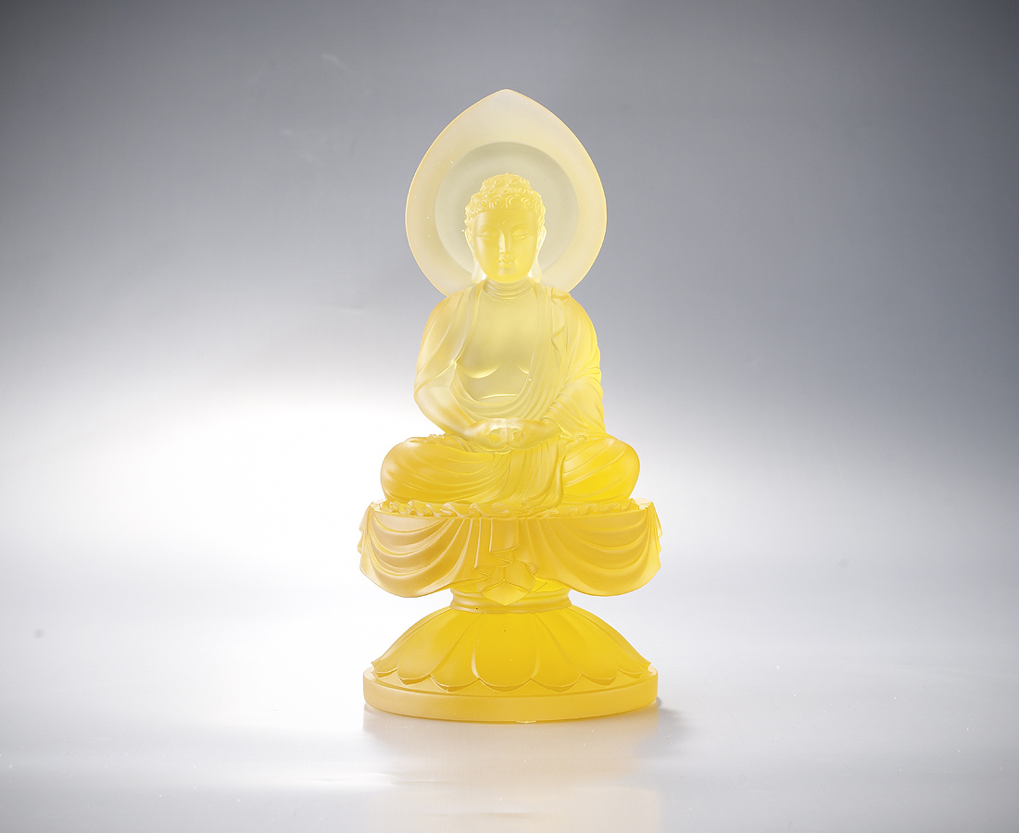
若有眾生 一心念我
諸罪消滅 得生極樂
廣度有情 終成正覺
The Grand Aspiration
Amitabha Buddha has determined that people who repeat the name of Amitabha will surely be raised to Elysium World upon death. Therefore, he heads the prayers for relief of sufferings and a happy afterlife in Elysium.

編號 | 1213317 | No | 1213317
名稱 | 無上發願 | Name | The Grand Aspiration
顏色 | 金 | Color | Golden
尺寸 | 10.9 * 10.9 * 21.6 | Size | 10.9 * 10.9 * 21.6
重量 | 2.0 | Weight | 2.0
限量 | O | Limited Edition | O
售價 | NT$ 19800 | Price | NT$ 19800
 | RMB$ 4300 |  | RMB$ 4300

